Within the Presence platform, we now have the ability to improve the styling of our current standard forms as well as the ability to customize these forms using simple/standard classes that are completely responsive and print out in a simple concise structure.

The following standard forms are available to all of our presence clients.

Available Standard Forms

**Generic Forms - These are for any genre in the healthcare industry.**

* _2017 Appointment Request
* _2017 Doctor Referral – Generic
* _2017 Feedback
* _2017 Refer a Friend
* _2017 Survey

**Dental Forms - These forms are specific to the dental field; however, some orthodontists also ask for these forms.**

* _2017 Adult Registration Form – Dental
* _2017 Child Registration Form – Dental
* _2017 Doctor Referral - Dental

**Orthodontic Forms - These forms are specific to the orthodontic field.**

* _2017 Adult Registration Form – Ortho
* _2017 Child Registration Form – Ortho
* _2017 Doctor Referral – Ortho

**Medical Forms - These forms are specific to general medical areas.**

* _2017 Adult Registration Form – Medical
* _2017 Child Registration Form - Medical
* _2017 Prescription Refill Request

## Step one – Saving standard forms for implementation on your website.

1. Log in to the administration area of the website using your username and password.
2. Once you have logged in, you will hover over the four colored dots in the left top corner of the screen and click ***“Forms Administration”***.

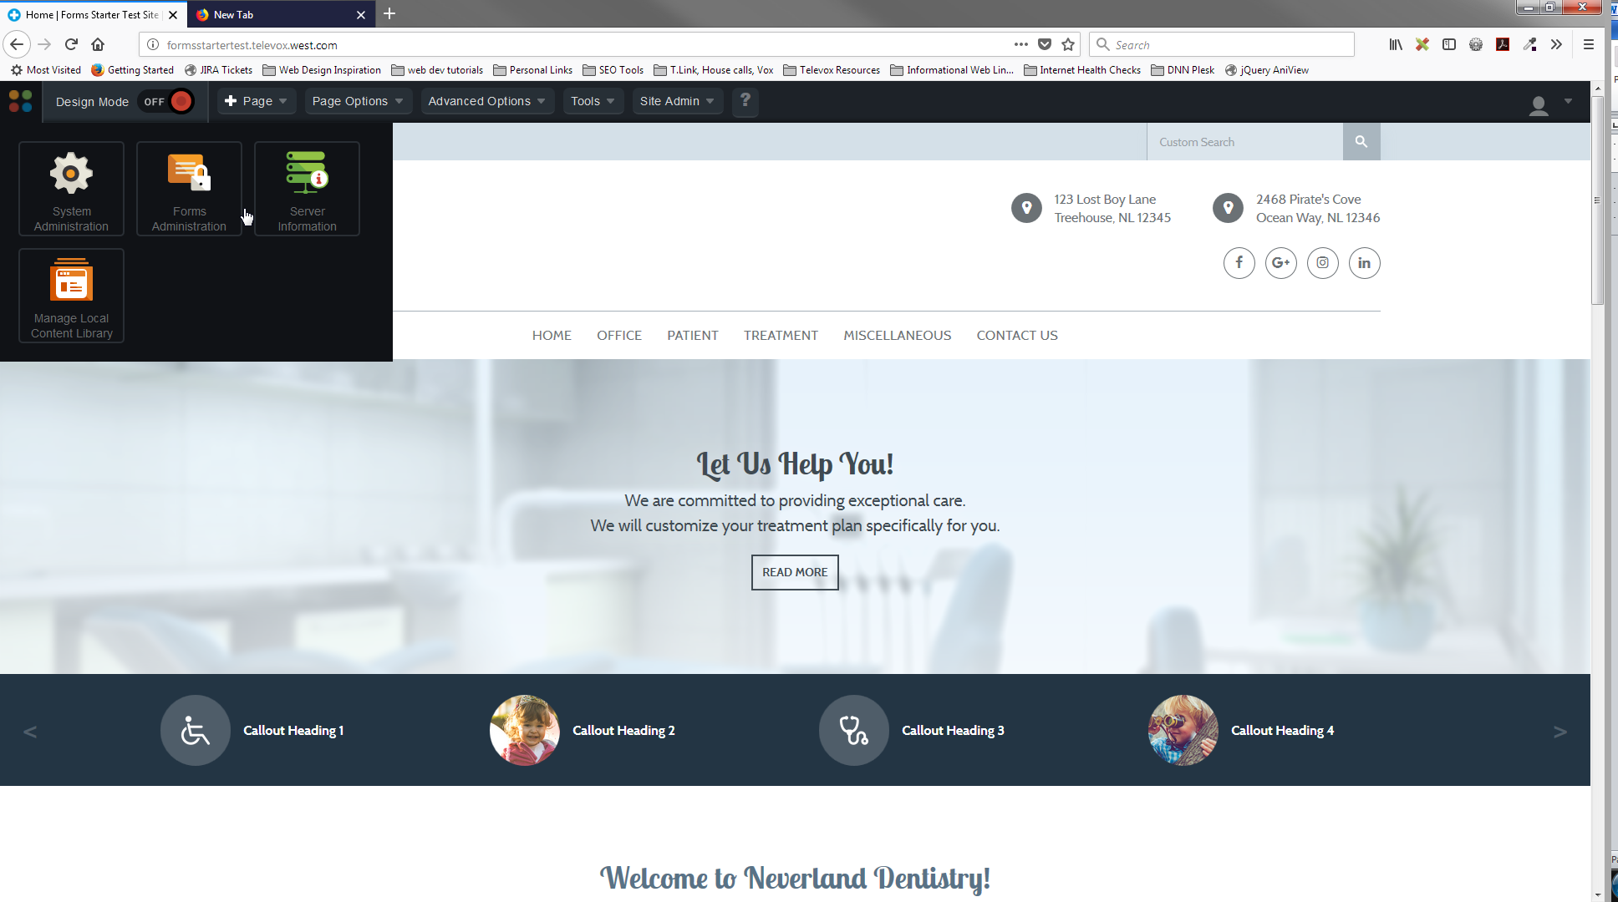

1. When you click on Forms Administration, it will take you to Secure Form Library. You will see a listing of all the standard forms under the “Global Form Templates” area.

**please note that you should ONLY use those forms with “_2017…” at the beginning of them.

1. When you see the form you want to install on your site, you will click the icon on the right hand side. It is listed under the action column.

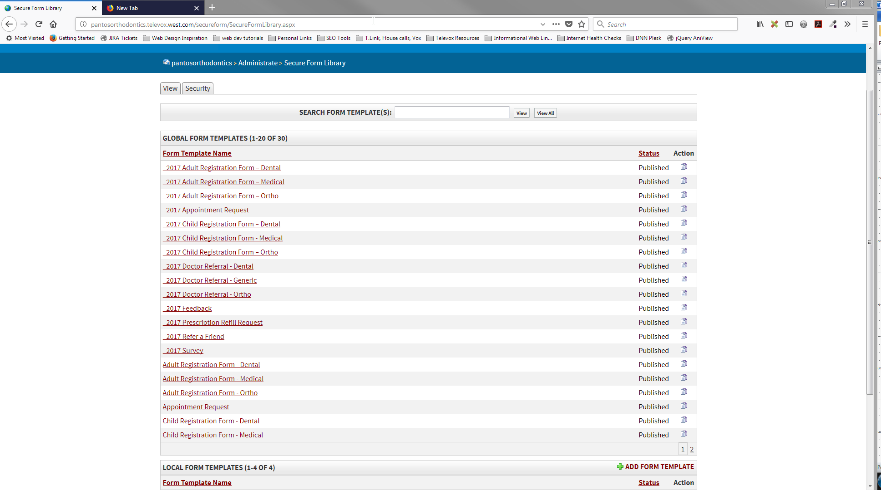

1. A window will pop up asking you to confirm that you want to copy this form to the local library. You will click ***“Confirm”***.

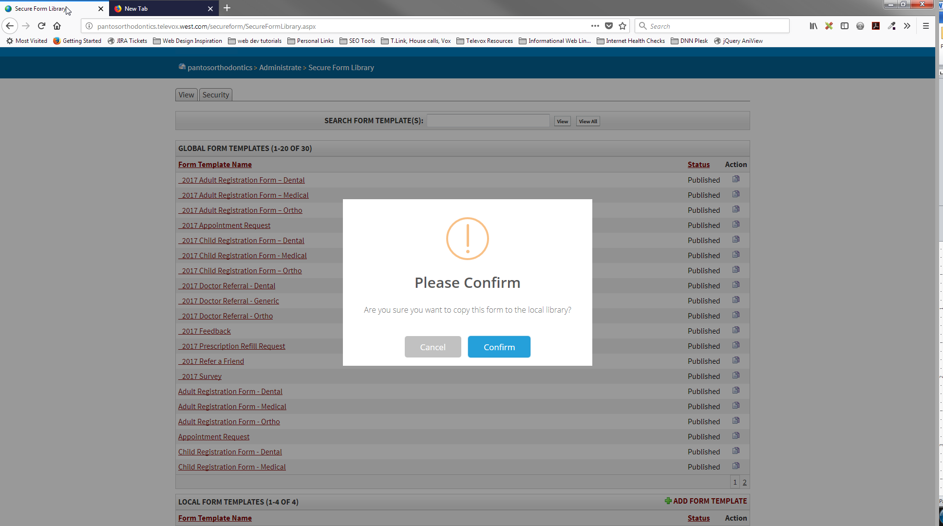

1. Clicking ***“Confirm”*** will bring you to a new screen.
2. On this screen, you will only change the areas listed below. They are all located in the “Form Details” section. (Please see the screenshot if you need help finding those areas.).
   1. You will also need to rename the form to describe what it is being used for on your site. For example: *“ _2017 Adult Registration form – Dental”* could be renamed as *“Adult Registration Form.” This information will print out at the top of the form.*

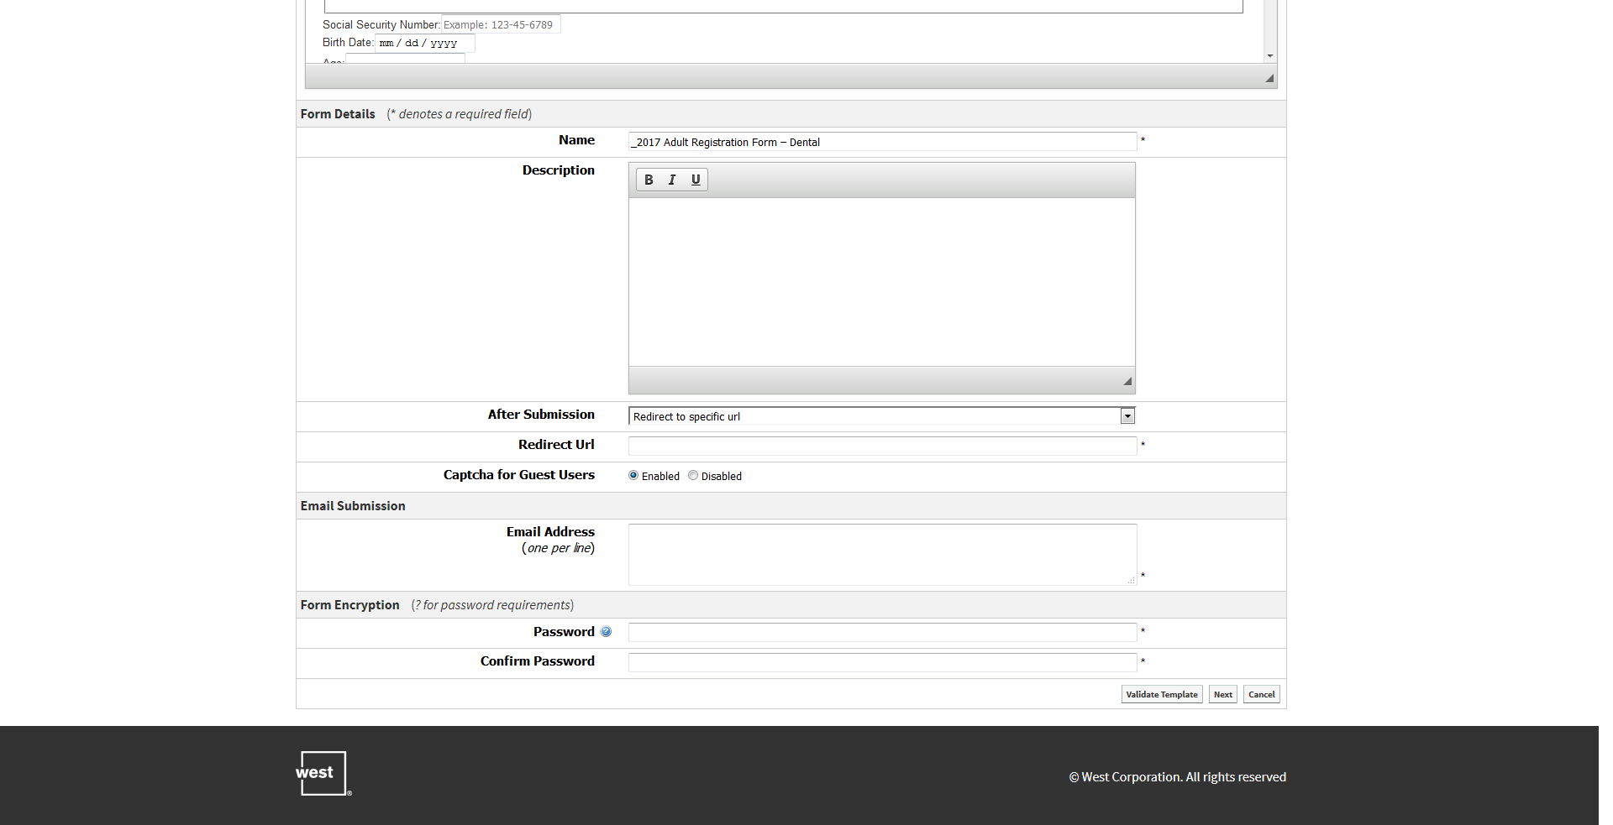

D

C

E

BG

A

* 1. ***“After Submission”*** – you will change this to “redirect to specific url”, then a new field pops up directly below.
  2. ***“Redirect Url”***, you will put the following text - */thank-you*

**please verify that there is a thank you page at that location.

* 1. ***“Email Address”*** – you may list multiple email addresses, but only one per line. Do not use commas to separate the email addresses and make sure that there are no spaces before or after the email address. This will cause the form to error when you try to save it.
  2. ***“Password”*** and ***“Confirm Password”*** – in this field, you will enter the same password that the client uses to log into their website.
  3. In the bottom right hand corner, you will then click ***“Next”***.

1. You are now at a new screen that shows each item in the form. Scroll to the very bottom of the page and click on the button labeled ***“Publish Form Template”***.

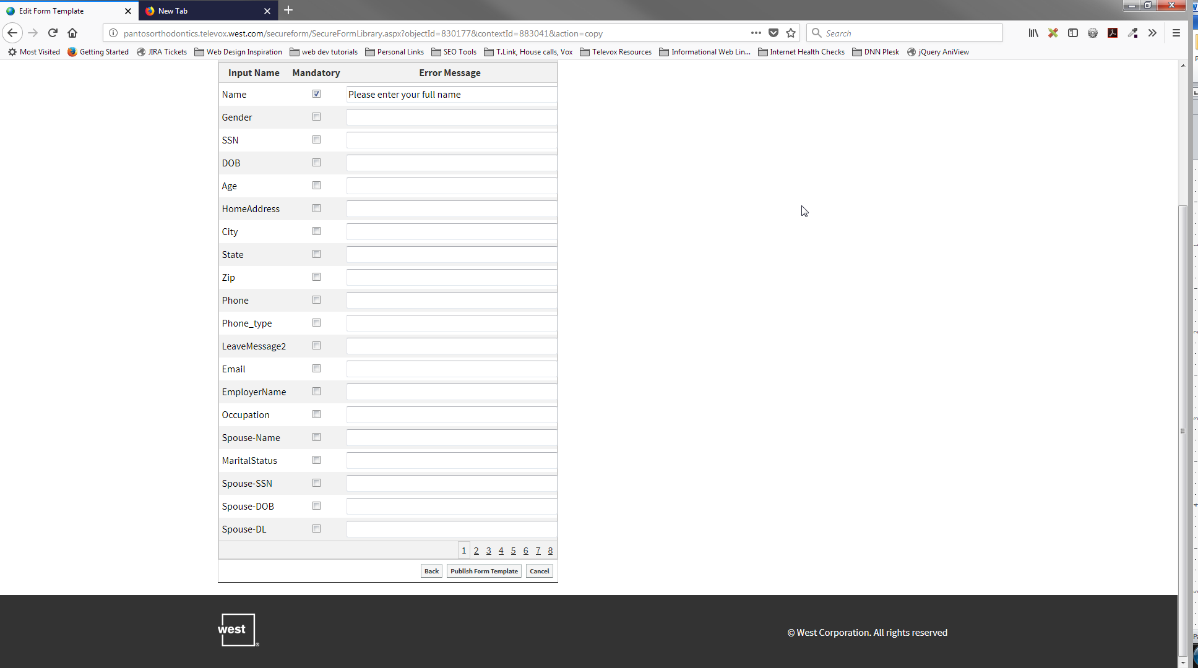

1. Once you click on this button, you will have successfully saved a standard form to your website.

**alternate submission option

1. Alternative to After Submission Redirect –
   1. In the After Submission” area, you may also select “Show Specific Thank You Message”.
   2. A new dropdown will show up directly below, titled “Submission Message.”
   3. In this field you will enter the message you would like to see displayed in a pop up window after submit is clicked.
   4. The standard message used is, *“Thank you! Your information has been submitted to our office. We look forward to seeing you soon.”*
   5. *If the client has another message they would prefer to use, this is where you would put it.*

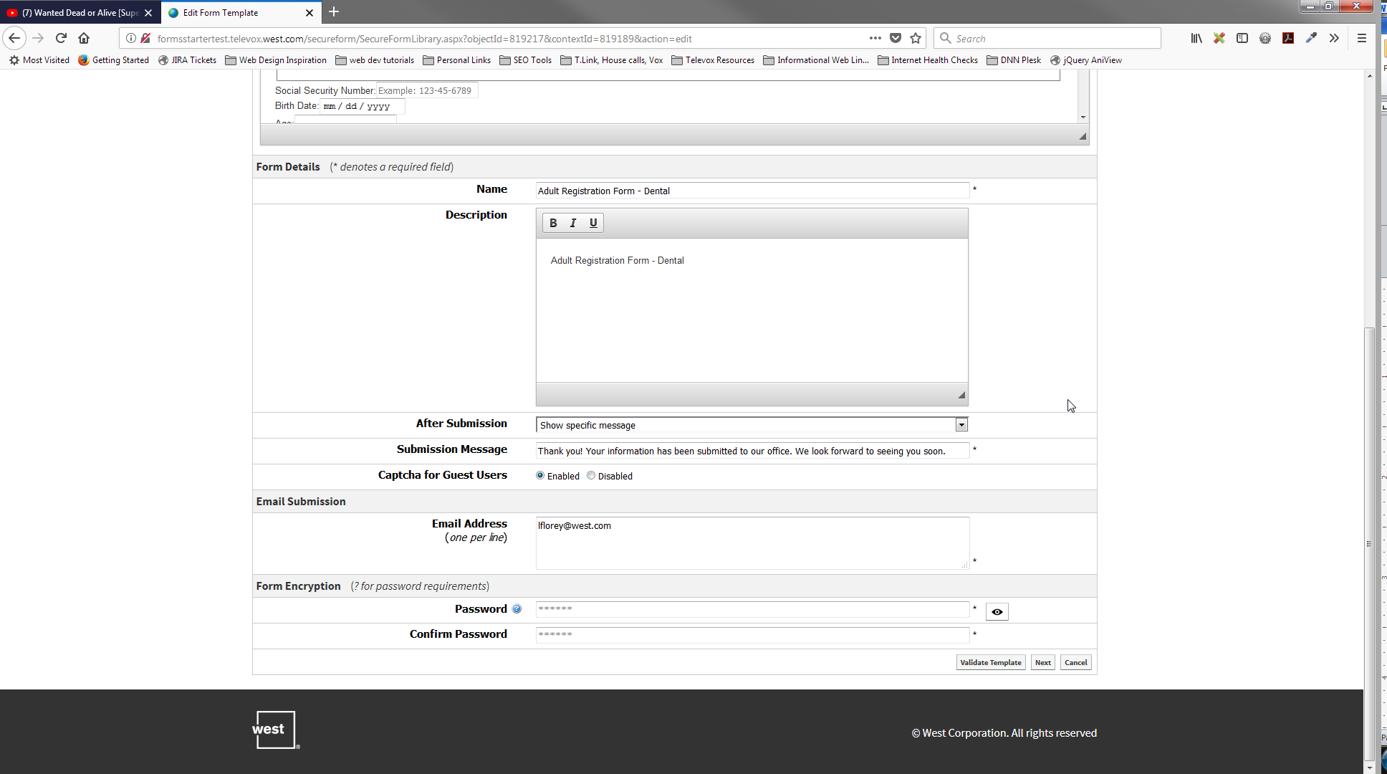

## Step two – Implementing a standard form on your website.

1. Go to your website and log into the administration area.
2. Navigate to the page where you would like to install the standard form.
3. On the page, you are going to click on the red button at the top of the screen labeled ***“Design Mode”***.

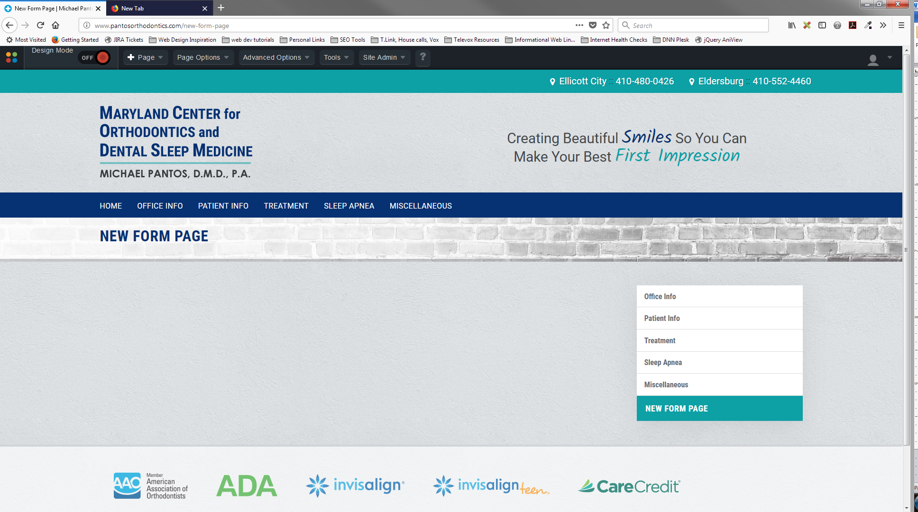

1. Your screen will now look like the screenshot below.

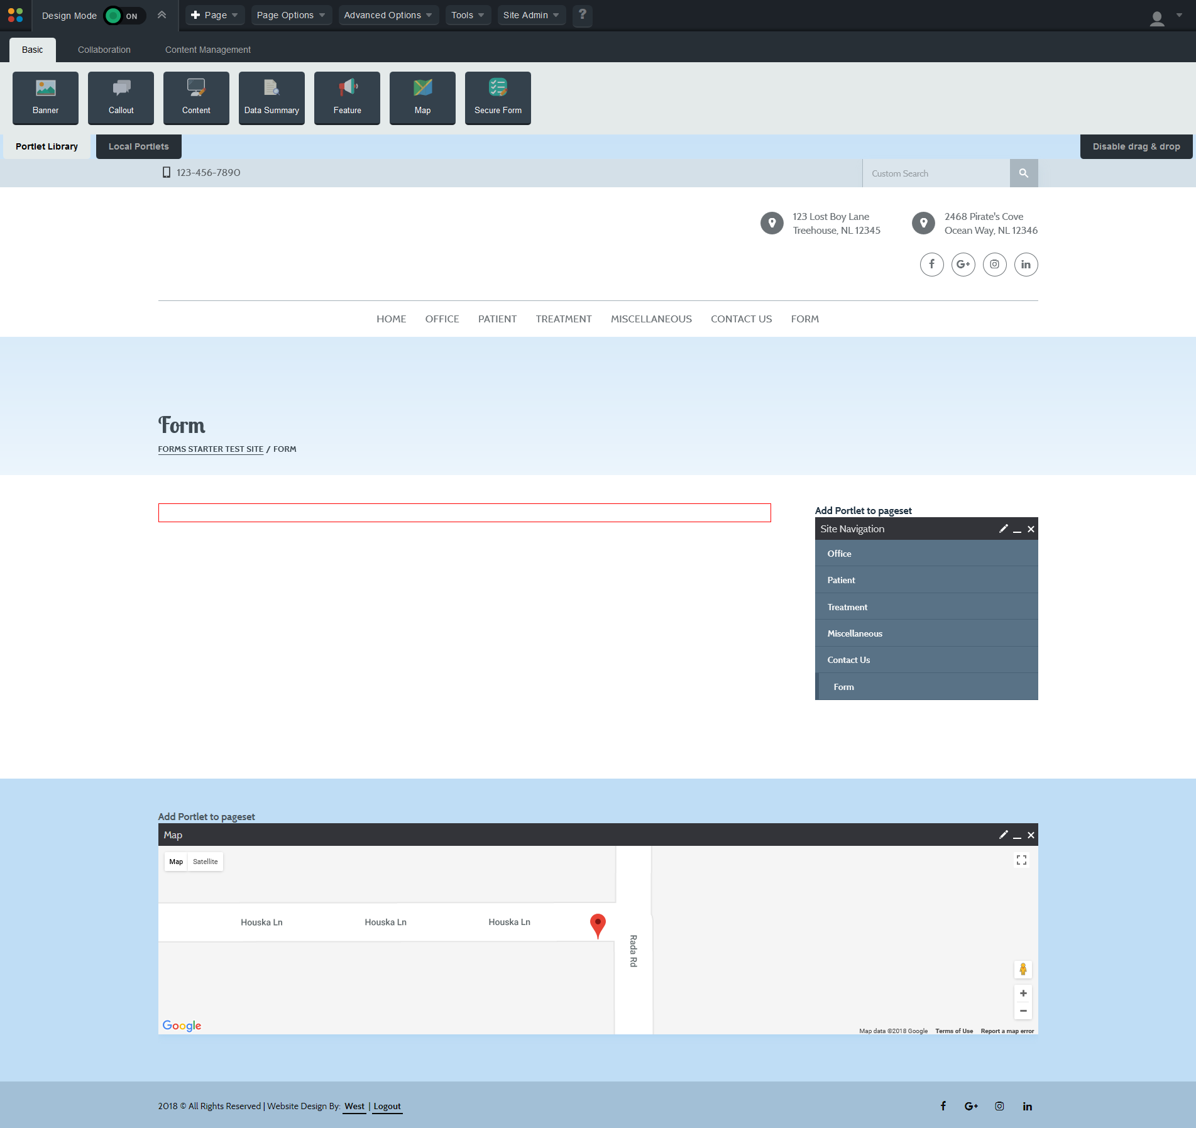

1. You will hover over the button at the top of the screen labeled ***“Secure Form”***.

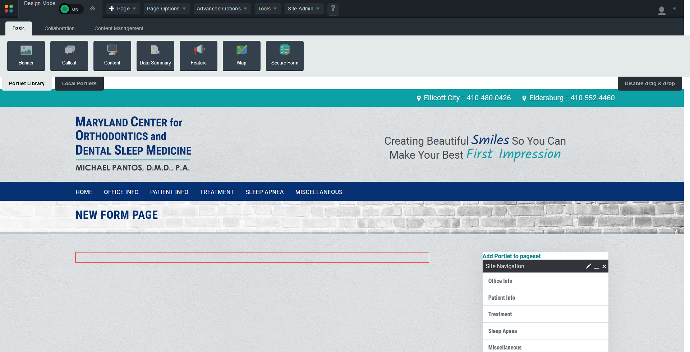

1. Holding your mouse down, you will drag that button into the red box on the page. The page should now look like the screenshot below.

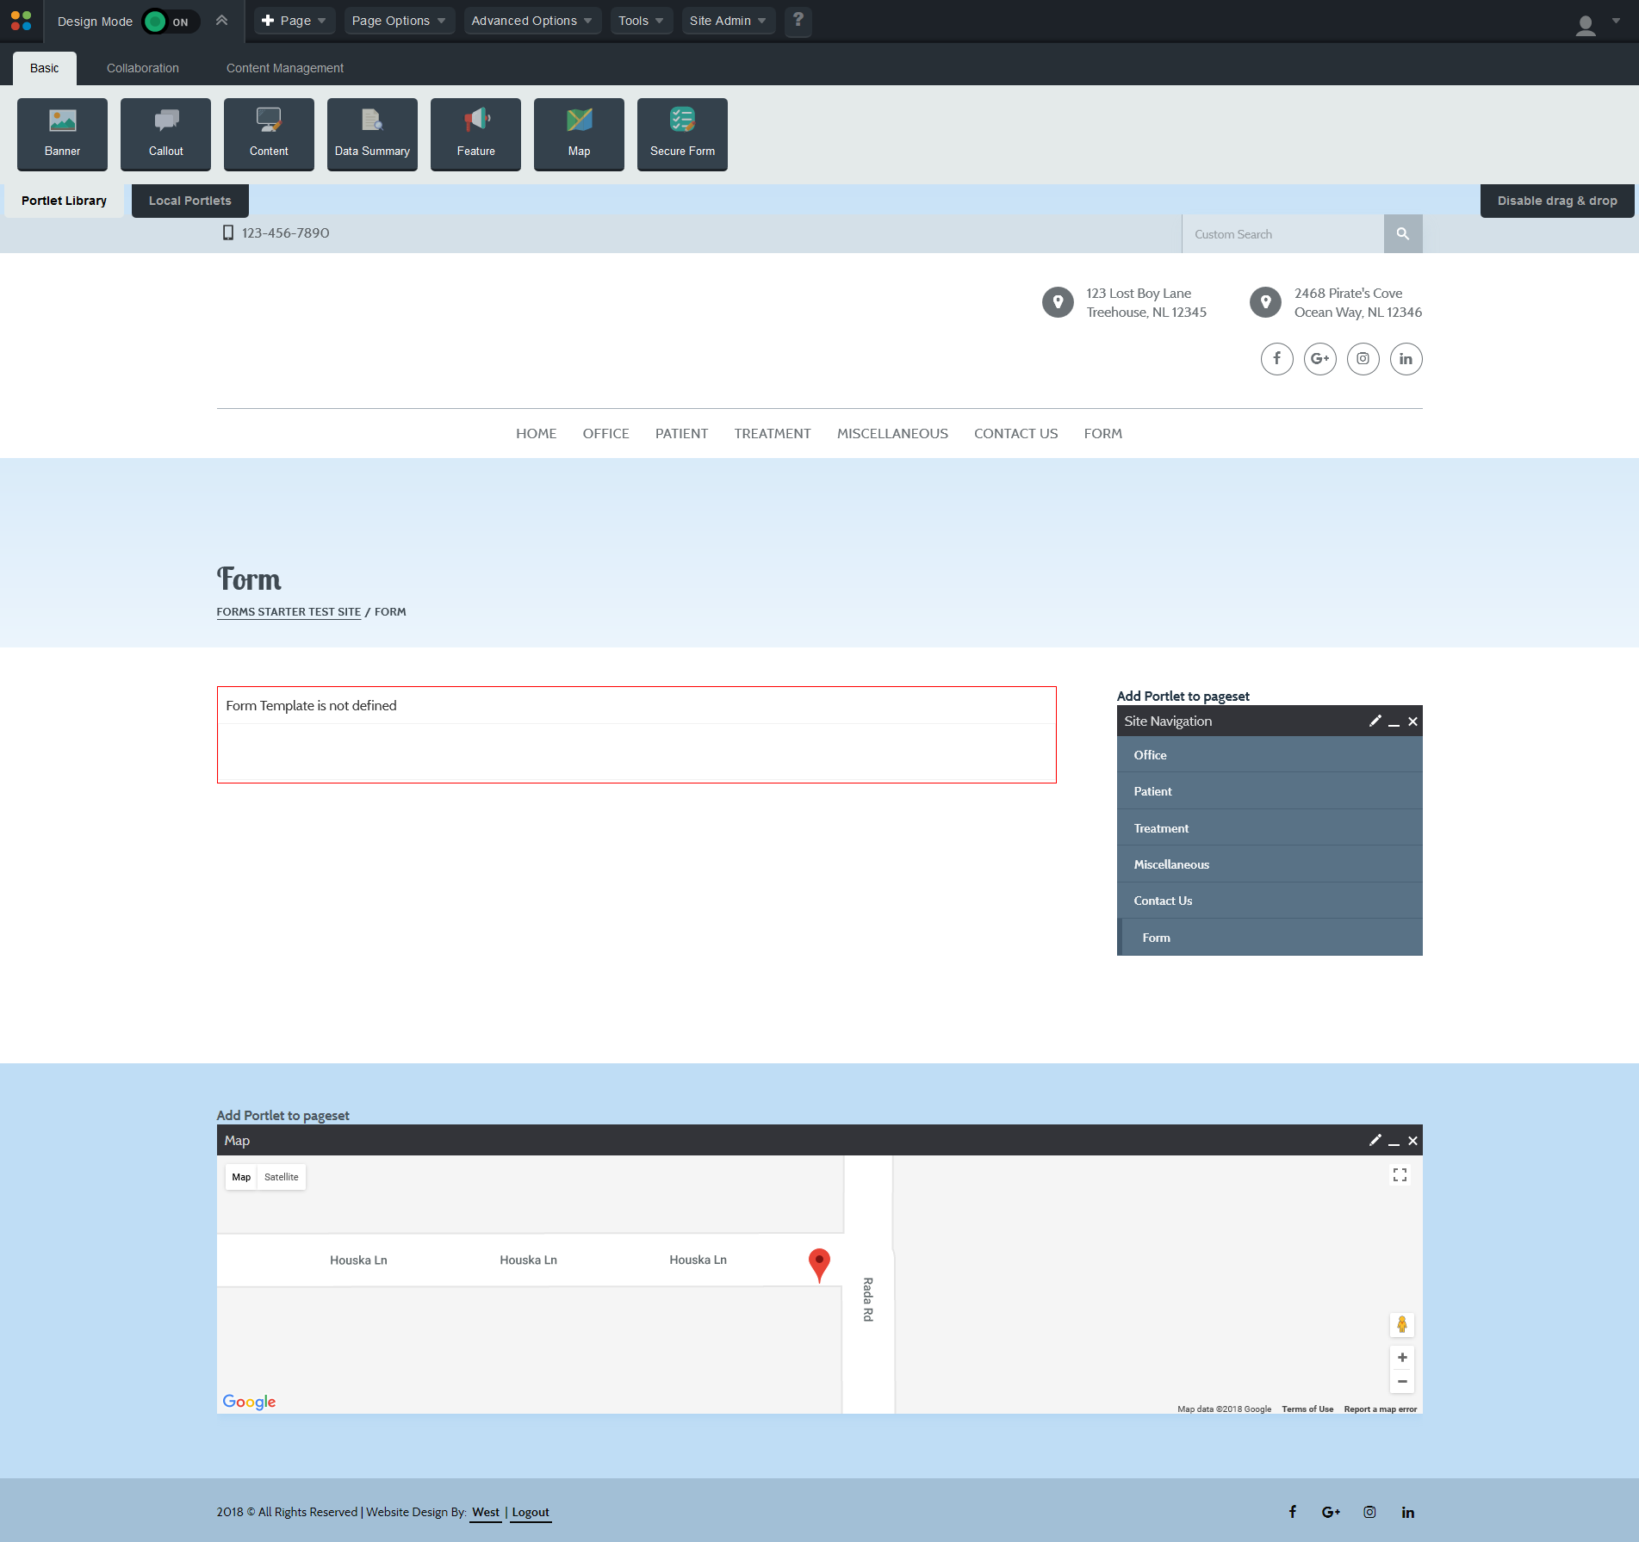

1. Hovering over the area inside the red box will cause an edit bar to show. Click on the ***pencil icon*** located in the right corner of this bar.

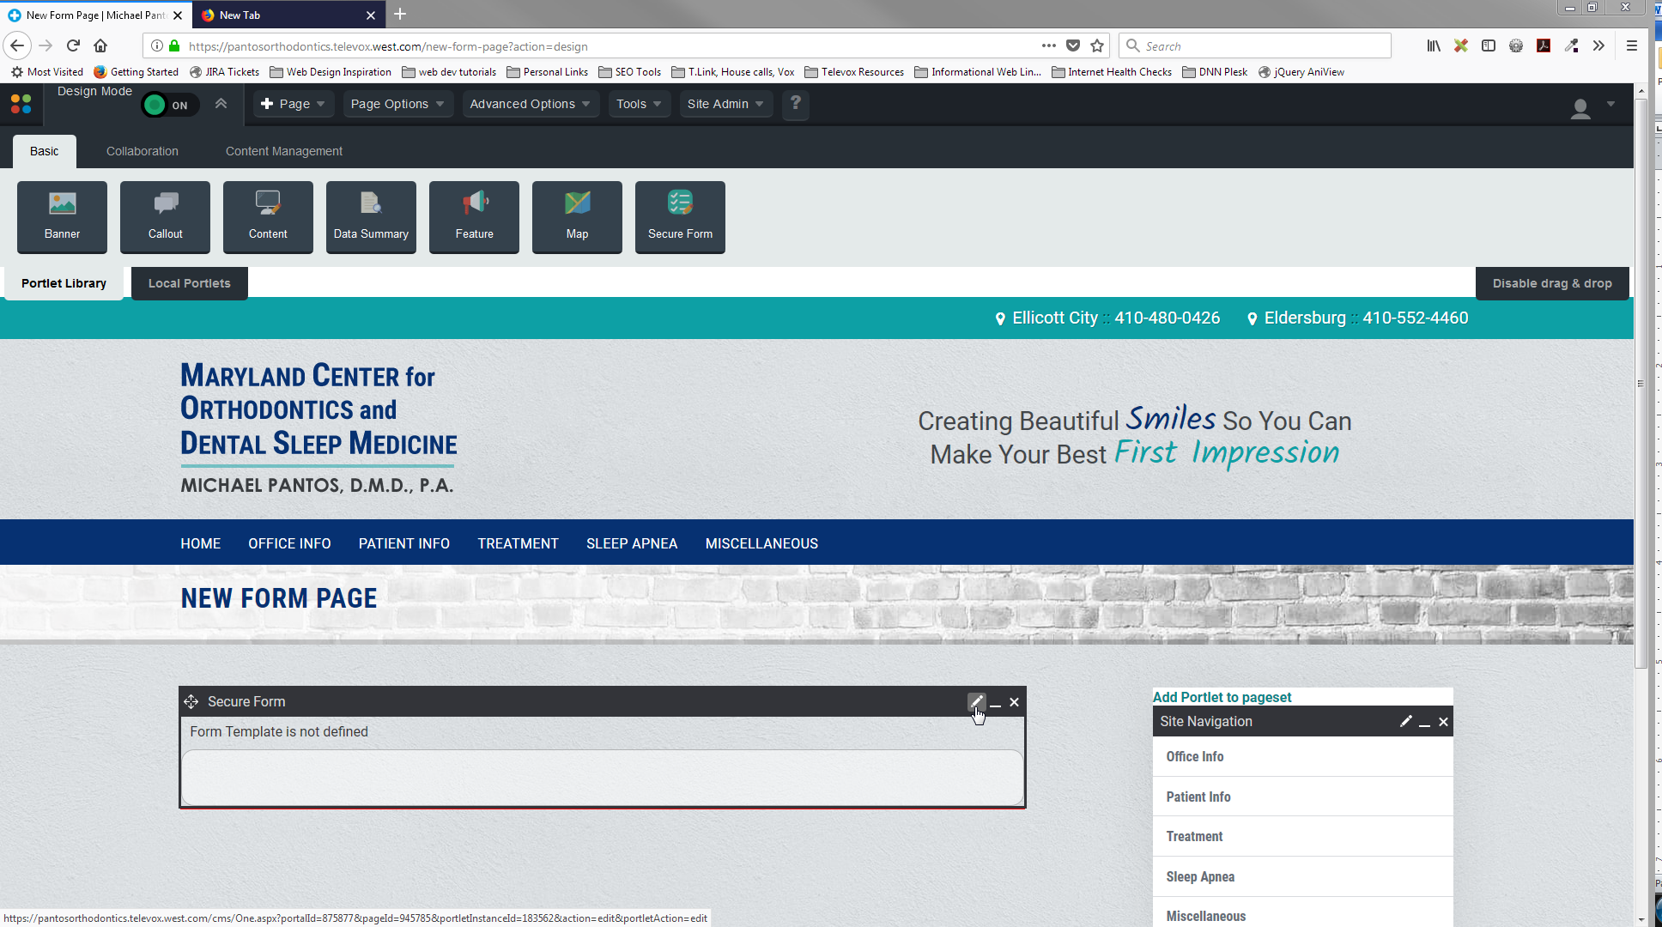

1. This brings you to a new screen. You will select the form you want to install on the page, here.
   1. Click on the dropdown in the field labeled “Form Template” and select the form you would like to install.
   2. In the last row of the “Template Details” area, you will see two radio buttons. Make sure the one-labeled ***“Use Defaults”*** is selected.
   3. Scroll to the bottom of the form and click ***“Save Form”***.

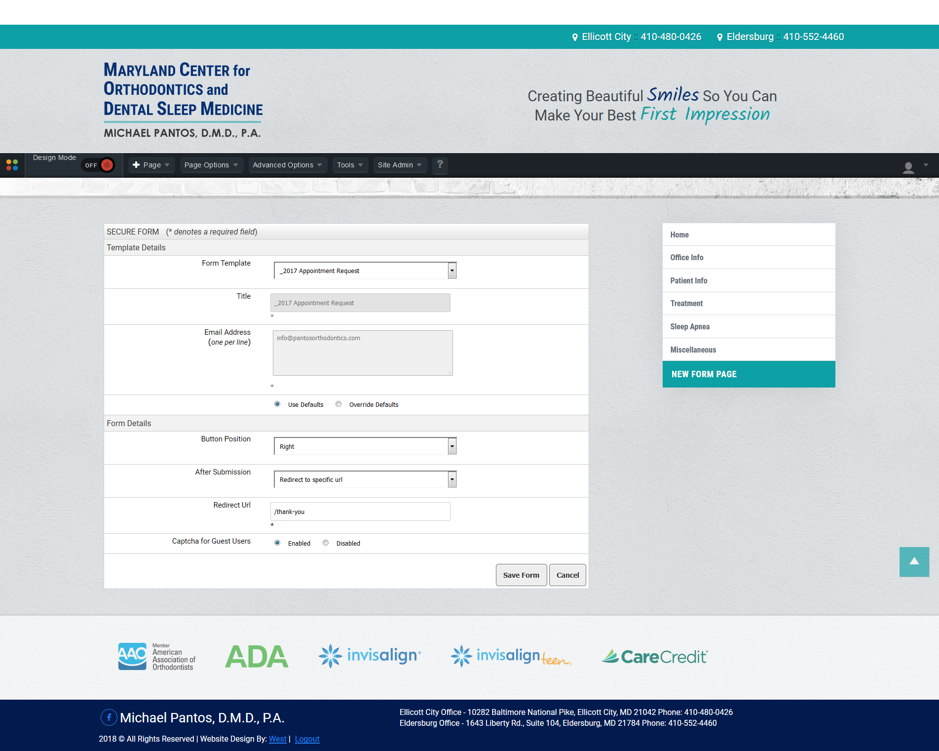

CG

BG

AG

Your form is ready to use on your website.