# Olympus Developer Documentation

With the introduction of our second custom Presence starter template also comes a slight change in processes when developing a starter with this template. This will serve as a reference document for the Web Services development team and will contain instructions on how to properly build a site on this new starter template.

## Step 1 – Setting up a new server for SASS compiling (One Time Setup)

You should only have to do this step one time; its purpose is to provide a quick and efficient way of customizing and compiling the SASS for each Neverland Starter site.

1. Open Dreamweaver
2. On the “Files” tab click the server dropdown, scroll to the bottom and click “Manage Sites”
3. On the Manage Sites pop-up click “New Site” in the bottom right

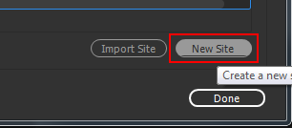

1. In the “Site Name” Field enter “2017OlympusStarter
2. In the “Local Site Folder” click the folder icon, create a new folder named 2017OlympusStarter, left click the folder and then click “Select Folder”

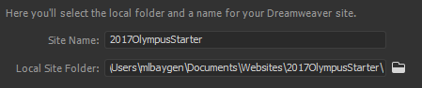

1. Keep the Site Setup pop-up open and in windows navigate to the P drive directory:
   1. **P:\WebDeveloper\Presence Platform\Starter Templates**
   2. Copy the “Design 2” folder to your clipboard
2. In windows navigate to the folder you just created for the new server and paste the Design 2 folder into it.
3. Back in Dreamweaver Click “Servers” from the left hand pane
4. Click the “+” icon in the middle of the right hand pane
5. This server information does **not** matter, we are simply creating a local server folder to compile CSS. Enter the following information into the fields:

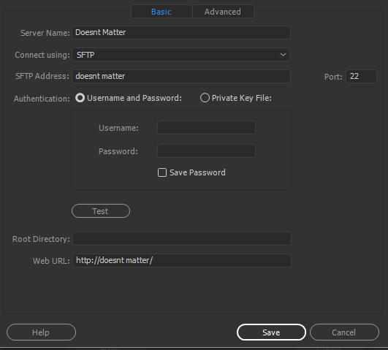

1. Click “Save”
2. Click “CSS Preprocessors from the left hand pane.
3. Uncheck “Enable autocompilation on file save”.
4. Click “Source & Output” from the left hand pane
5. Click the “Define output folder” radio button and then click the folder icon to the right

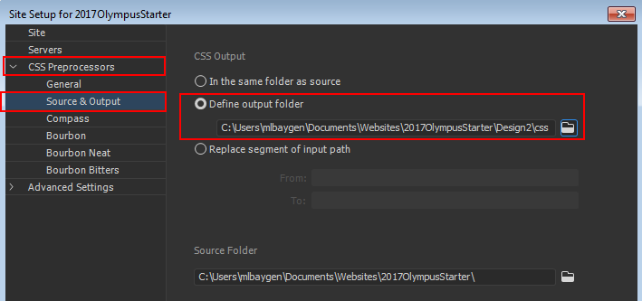

1. In the “Choose Output Folder” window double click the “Design 2” folder
2. Create a folder named “CSS” inside of the “Design 2” folder
3. Click the CSS folder and then click “Select Folder”
4. Click “Save”, and then click “Done” on the “Manage Sites” pop-up.

You are now setup and ready to compile your 2017Olympus SASS styles!

## Colors

In Dreamweaver go to your 2017OlympusStarter server. In the files panel expand the “Design 2” folder, next expand the “SCSS” folder. Open the file named “_variables.scss”.

At the very top you will see 5 variables starting with $color-primary1. Change each of these variable values to the corresponding hex values provided on the blueprint.

The predefined color palettes can be found at the bottom of _variables.scss.

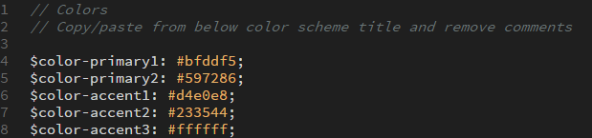

## Fonts

In order to customize your font package to match the blueprint you must copy and paste a font block from the bottom of **_variables.scss** and paste it over the existing font block. Finally you must remove the comments from all the lines that start with a “**$**” or “**@**”. Simply put, do not remove the two forward slashes before the font name.

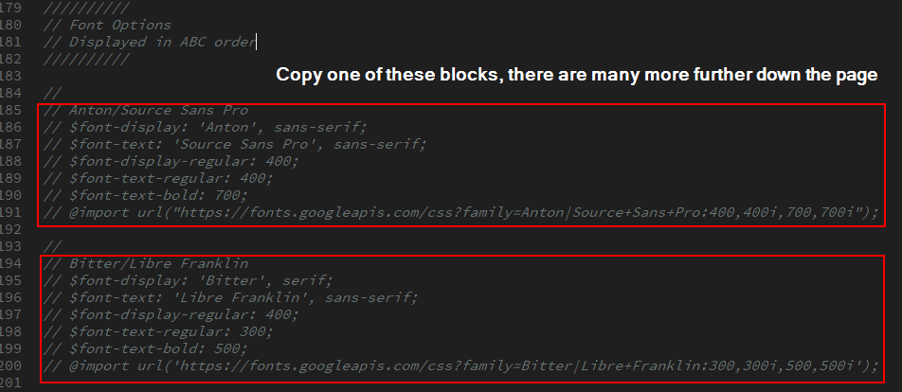

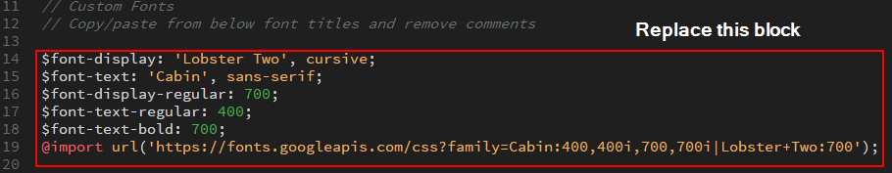

### *Trick* If you position your cursor here:

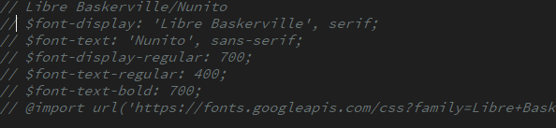

Hold “**alt**” and drag your cursor to the left and then down the page and you can easily select all the comment syntax:

*Note* Be sure you only delete the //’s that are in front of lines of code.

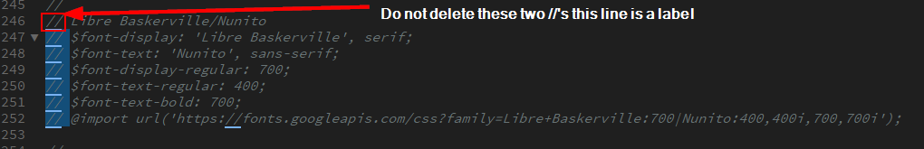

## Color Scheme (Light or Dark)

The color scheme variable determines which color publish link icon to pull. The first time you select light or dark you will be performing an educated guess. The best way to do this is to examine your **accent1** color. If this color is a lighter color change the “**$scheme**” variable value to light, if **accent1** is a darker color change the “**$scheme**” variable value to dark. After compilation, if the phone and published link text color doesn’t match the icon color, change the $scheme variable and recompile.





## Compiling

### Pre Compiling Checklist

Before you compile ensure you have done the following:

1. Adjusted your colors
2. Set your fonts

### How to Compile:

Compiling your scss folder takes your color/variable values and generates a **style.css** file. You will then paste the contents of this file into the bottom box of the template editor in Presence.

1. In Dreamweaver ensure you have your 2017OlympusStarter server open.
2. Expand the Design2 folder so that the SCSS folder is visible.
3. Right click the SCSS folder and click “Compile”
   1. Note this will take about 1+ minute, be patient.

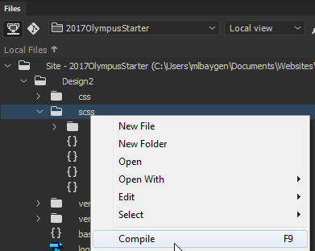

When your file is finished compiling your output tab at the bottom of Dreamweaver will show the following:



*** If there are **ANY** errors you must check your _variables.scss and **RECOMPILE.**

### Post Compilation

Expand the “**CSS**” folder you created earlier and copy the contents of “**style.css**”. Paste this into the bottom styles box of your site template editor. *Note* if the site contains added site-specific styles they should be located and commented at the top of this box, do **NOT** replace these styles. Replace all the styles below with the contents of your compiled **style.css.**

## Addresses

### If an office has 2 or less locations:

#### Footer

1. Navigate to Administrate > Manage Portal Themes > Click any Theme > Customize > Copy & Paste Template Markup into Dreamweaver.
2. Find the UL with the id “**footerLocations**”. Edit the markup to match your site’s address. If your site only has one address delete the second LI.

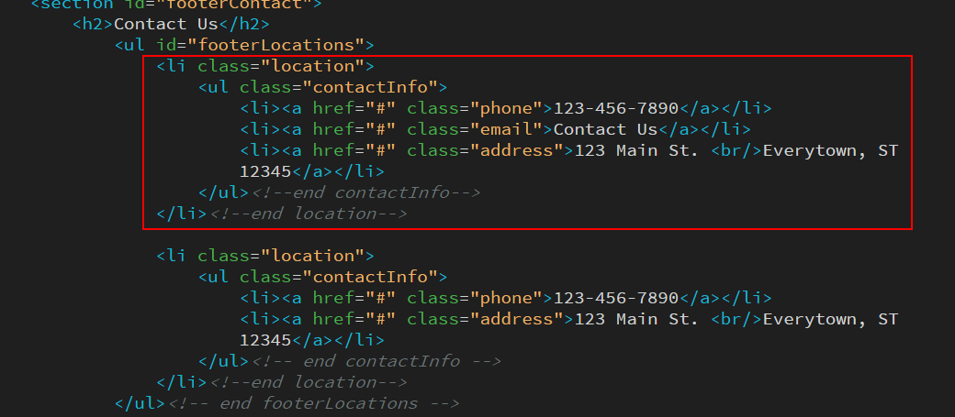

### If an office has 3 or more addresses:

#### Footer:

1. Navigate to Administrate > Manage Portal Themes > Click any Theme > Customize > Copy & Paste Template Markup into Dreamweaver.
2. Find the UL with the id “**footerLocations**”. Edit the markup to match your site’s address. If your site only has more than two addresses duplicate the LI and add as many as you need.

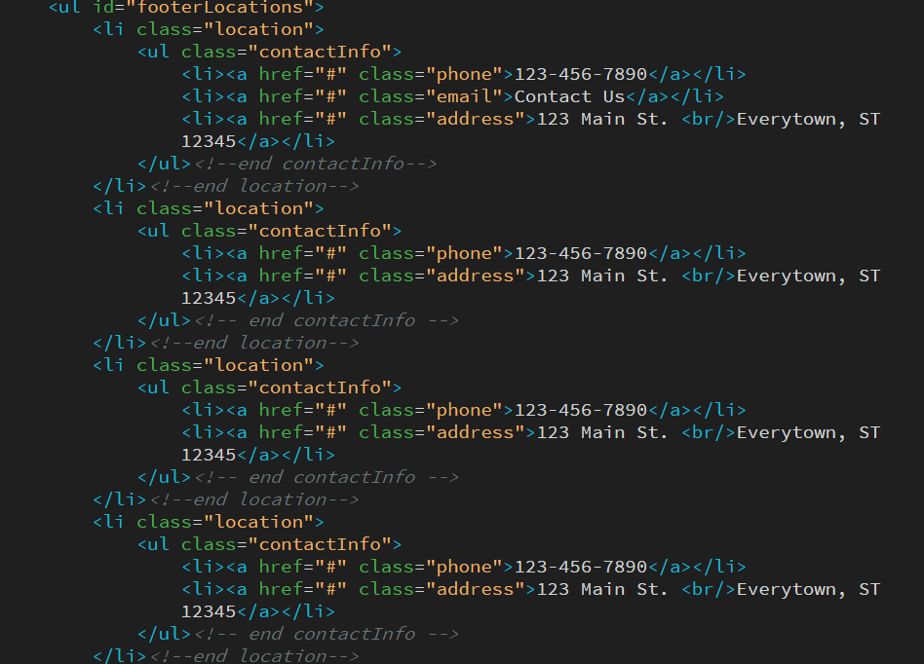

1. Next delete the entire “<section id=“hours”>” HTML block.

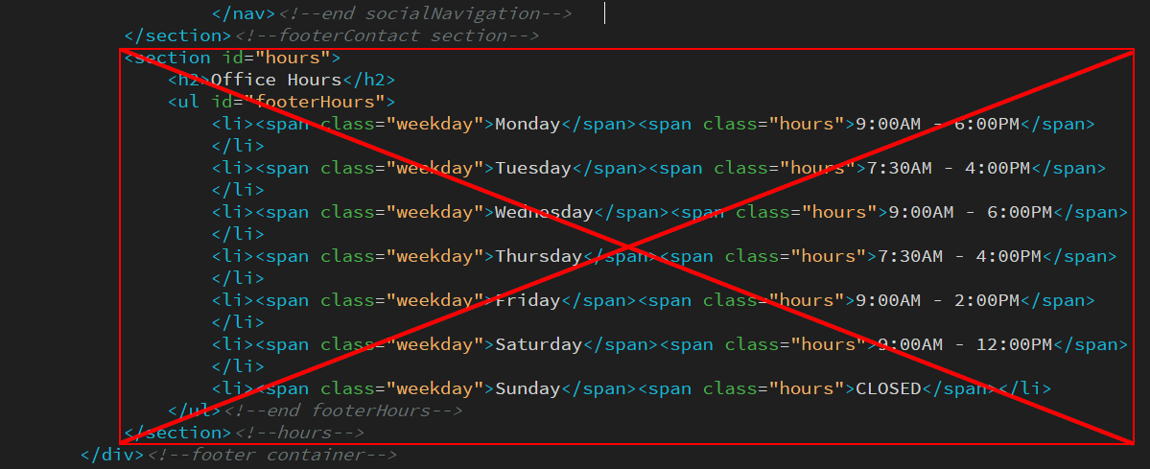

1. Copy your altered template code and paste it into the Presence backend. Click “**Update Template**”

You will notice that the middle “**Contact Us**” section in the footer has expanded over to where the office hours used to be. This is all thanks to flex-box!

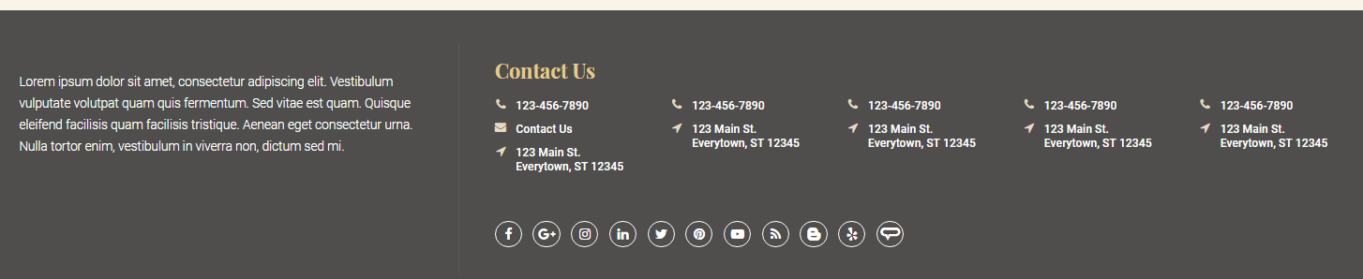

## Header Phone Number

Editing the primary phone number for the Neverland starter is very simple! Open Manage Portal themes, and then click “**Customize**” to go to the template editor. In the template locate the following code and change it to the new value:

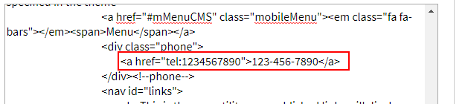

## Custom Search Box

1. Navigate to: <https://cse.google.com/cse/all>
2. Login with the Televox credentials:
   1. E-mail: televox17@gmail.com
   2. PW: Telepass!7
3. Click “**Add**” below “Edit Search Engines”

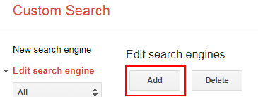

1. On the next window insert the **live site url** (without televox.west.com) into the “**Sites to search**” box. Leave the second box **empty**.

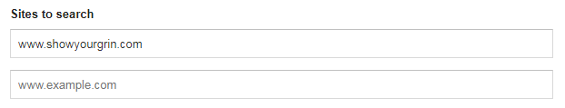

1. Click “**Create**” and on the next window click “**Get Code**”
2. Click “**Look and feel**” from the left hand navigation.
3. Click “**Results Only**” and then click “**Save & Get Code**”
4. Copy the top portion of the given code and paste it into notepad.

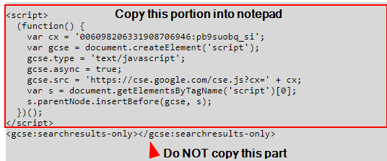

1. Navigate to the home page of your site and login as **admin**.
2. Click “**+ Page**” in the top left and then **click content space page**.
3. In the **Title** field name this page “**Search Results**”, the **Name** field should be “search-results”.
4. Click “**Create Page**”.
5. You should automatically be redirected to the new Search Results page, if not go ahead and navigate to this page.
6. From the top admin bar go to “**Page Options**” and then click “**Page Layout**”

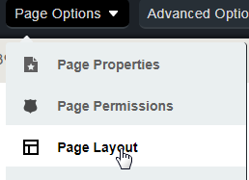

1. On the “**Edit Layout**” popup click the radio button labeled “**Custom**”.
   1. Paste the following code into the “**Custom Layout**” box:

**<template>&lt;gcse:Searchresults-only&gt;&lt;/gcse:Searchresults-only&gt;<column order="1" /></template>**

* 1. Click “**Check validation**”, the markup should validate.
  2. Scroll down to the bottom of the “**Edit Layout**” pop up and click “**Update Page**”.

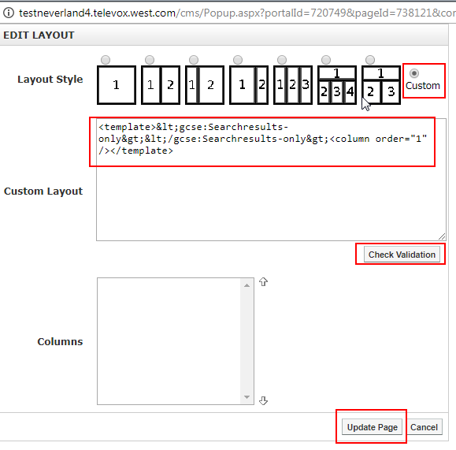

1. Navigate to **Administrate** and then **Manage Portal Themes** click “**Customize**” to go to the template editor.
2. Paste the following code into <div id=“topBar”> just before <div id=“showLinks”>:

**<div class="searchBox">&lt;gcse:Searchbox-only resultsUrl="/search-results"&gt;&lt;/gcse:Searchbox-only&gt;</div><!-- end searchBox -->**

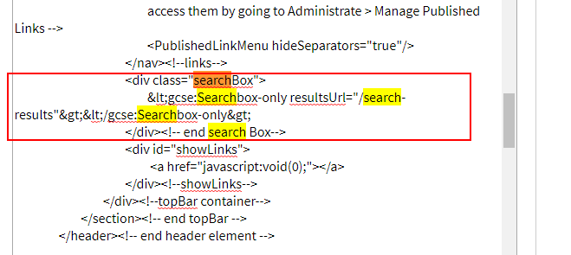

1. Next open **notepad** and copy the code you pasted into it earlier from Google.
2. Paste this code into your template directly before the closing “**HTMLhead**” tag.

Return to your site and the search bar should appear. **Note that search results will not show up until the site is live.** Test your search box by typing a term and pressing enter, ensure your search page looks correct.

The last step to adding a search box is to return to the home page and click “**Page Options**” and then “**Page Status**” from the dropdown. Click “**Hide Selection**” on the **Search Results** page and then click “**Close**”. The webpage should refresh and Search Results should no longer appear in the main menu.

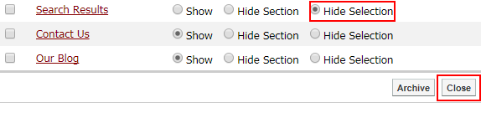

## Banner Images

**The 2017 Olympus Starter template does NOT have or offer a slideshow on the home page.** The template’s banner contains two content portlets. The first content portlet is used for the banner background image, simply edit the content portlet and insert an image via the image manager. Clients can request to change this banner feature image to a photo of their office or to one of our newly uploaded Neverland banner images. Suggested dimensions are: **1920px width x 1280px height. Be sure all new images are compiled to under 150kb(use** [**http://compressjpeg.com/**](http://compressjpeg.com/)**, add image, hover and click settings cog to adjust compression as low as possible), any quality lost will be masked by CSS blur.** Note if the feature contains a lot of text the image will fade into a solid color to accommodate.

**\*Note* The “help” blurb indicated by a dotted border and an info circle is NOT an actual portlet area. This is hard coded into the page layout. Also, when a user is logged in the banner image will not display as a background image, but rather as a regular static image in the banner.**

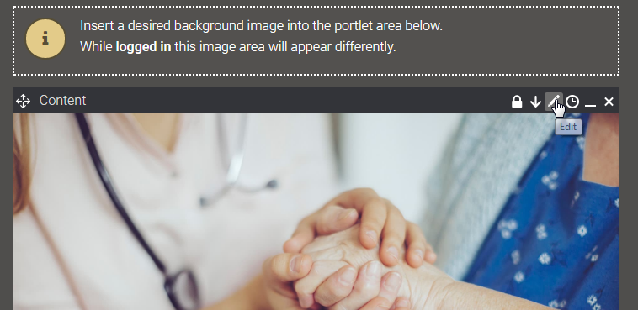

The banner text consists of a sub header and a h2 header. To edit this text simply hover over the second content portlet in the banner and click the pencil icon.

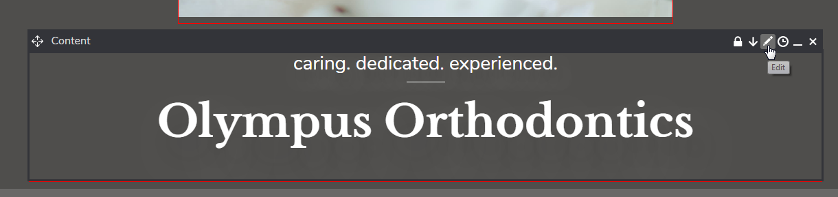

Change the sub header and header text to match the client’s provided text. *NOTE* when you edit this HTML you MUST use the following markup:

**<span class="subHead">caring. dedicated. experienced.</span>**

**<h2>Olympus Orthodontics</h2>**

## Featured Images

The 2017 Olympus Starter template contains **one featured image per main menu item**. These featured images appear behind the h1 and breadcrumbs on every interior page. *Note* when logged in the texture overlay will not display on top of the overview area.

### Guest / Not logged in Appearance:

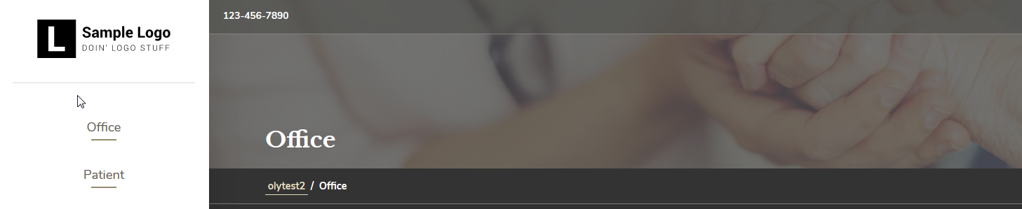

### Logged In Appearance:

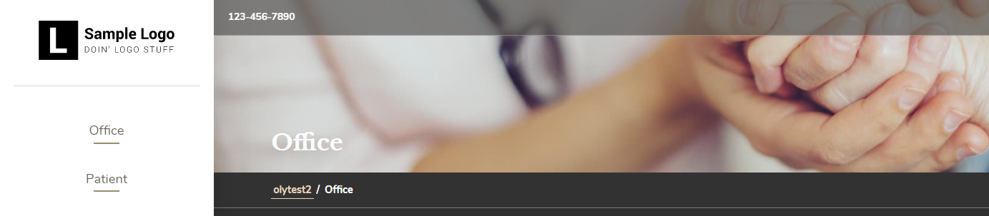

We can customize these images for our clients by following these steps:

1. Navigate to the **Main Menu Parent Page** ex: (Office, Patient, Treatment, etc..)
2. On the admin bar click **Page Options,** and then **Page Properties.**
3. On the **Page Properties** pop up ensure that the **Theme** field is set to the interior theme and **NOT** inherit.
4. On the **Featured Image** field click the **Folder & Hour Glass** icon.
5. Just like we did for the banner image, ensure you are navigating the **Global Image Library** and go to: **Starter Resources > 2017 Olympus > Banner Images**.
6. Click any of the images in this folder and then click “**Insert**”.
7. Click “**Update Page**”

The image will appear as long as the theme is manually set to the interior theme and a featured image is selected.

## Interior Office Hours

The 2017 Olympus Starter template contains a hard coded content portlet on every interior page which displays **Office Hours**. This content portlet can be customized to contain any responsive content the client wishes to add.

To edit the content of this portlet:

1. Navigate to any interior page and turn **design mode on**.
2. Hover over the “**Office Hours**” content portlet and click the pencil icon.
3. Edit the hours or content to your liking.
   1. If you are simply updating the hours I’d highly suggest using HTML mode so you do not compromise the markup of the portlet.
   2. If you are adding other content be sure to test it all the way down to **320px** in width.
4. Click “**Save**” in the top left.

## Interior Emergencies Blurb

The 2017 Olympus Starter template contains a hard coded content portlet on every interior page which displays **Emergencies**. This content can be removed, or customized to match the client’s information.

To edit the content of this portlet:

1. Navigate to any interior page and turn **design mode on**.
2. Hover over the “**Emergencies**” content portlet and click the pencil icon.
3. Edit the emergencies information and/or add content to your liking.
   1. If you are simply updating the emergency information I’d highly suggest using HTML mode so you do not compromise the markup of the portlet.
   2. If you are adding other content be sure to test it all the way down to **320px** in width.
4. Click “**Save**” in the top left.

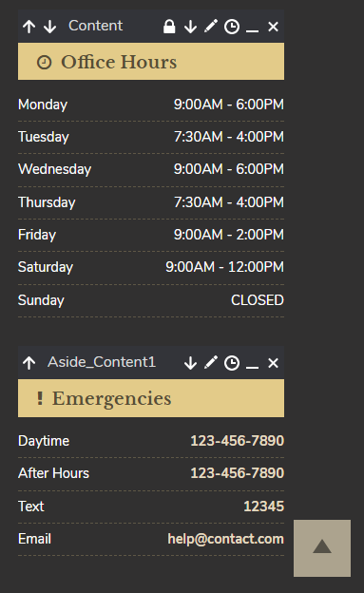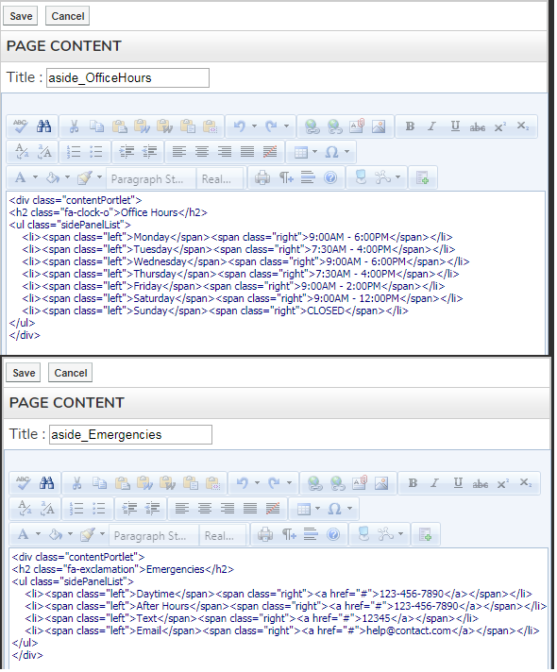

## Miscellaneous

### What if there’s additional custom CSS?

If the required CSS only needs to be on a single page please add it to a content portlet via style blocks. If for some reason your site requires additional global CSS you are to add it inside the commented custom CSS section. **\*Note* If you edit a site or have to recompile for whatever reason be very careful not to paste over the custom CSS section. You must also move the font @import statement to be at the very top of the stylesheets text box.**

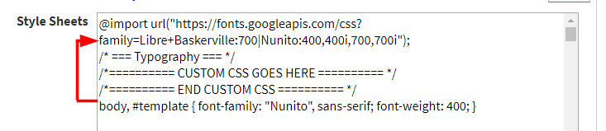

## What if two of the provided hex values are the same?

If two of your colors are identical on the blueprint simply **slightly** change one of the colors to be lighter or darker.

## Disable Telerik Menu Animations

**Whenever you build one of the new starters, Neverland, Olympus, or Atlantis. You need to disable the Telerik animations.**

**Administrate > Manage Control Settings > Telerik CMS Menu Tab**

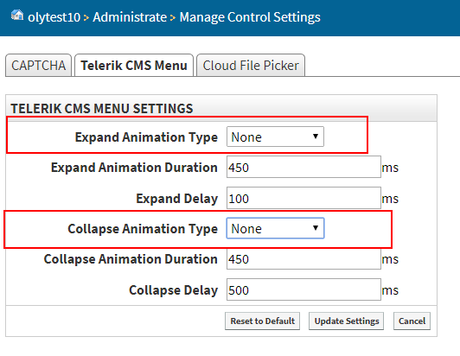

Be sure both of the boxes highlighted above are set to None.