# Atlantis Developer Documentation

With the introduction of our third custom Presence starter template also brings a slight change in processes when developing a starter with this template. This will serve as a reference document for the Web Services development team and will contain instructions on how to properly build a site on this new starter template.

## Step 1 – Setting up a new server for SASS compiling (One Time Setup)

You should only have to do this step one time; its purpose is to provide a quick and efficient way of customizing and compiling the SASS for each Atlantis Starter site.

1. Open Dreamweaver
2. On the “Files” tab click the server dropdown, scroll to the bottom and click “Manage Sites”
3. On the Manage Sites pop-up click “New Site” in the bottom right

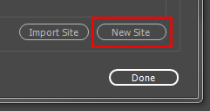

1. In the “Site Name” field enter “2017AtlantisStarter”
2. In the “Local Site Folder” click the folder icon, create a new folder named “2017AtlantisStarter”, left click the folder and then click “Select Folder”

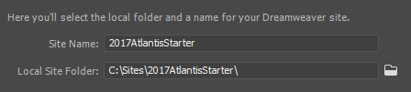

1. Keep the **Site Setup** pop-up open and in windows navigate to the **P** drive directory:
   1. **P:\WebDeveloper\Presence Platform\Starter Templates**
   2. Copy the “Design3” folder to your clipboard
2. In windows navigate to the folder you just created for the new server and paste in the **Design3** folder
3. Back in Dreamweaver Click “Servers” from the left hand pane
4. Click the “+” icon in the middle of the right hand pane
5. This server information does **not** matter; we are simply creating a local server folder to compile CSS. Enter the following information into the fields:

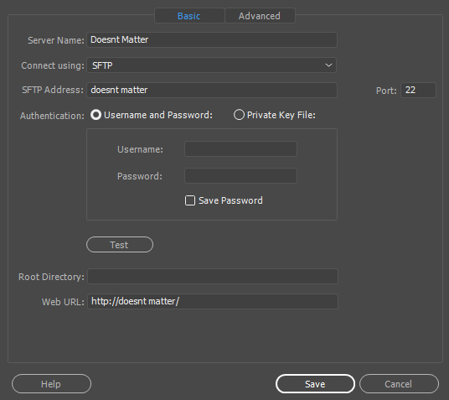

1. Click “Save”
2. Click “CSS Preprocessors” from the left hand pane
3. Uncheck “Enable autocompilation on file save”
4. Click “Source & Output” from the left hand pane
5. Click the “Define output folder” radio button and then click the folder icon to the right

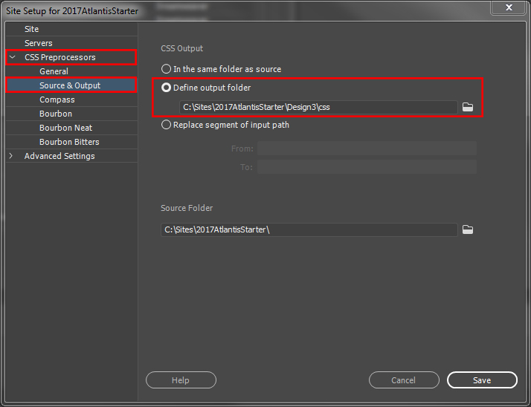

1. In the **Choose Output Folder** window, double click the “Design3” folder
2. Create a folder named **css** inside of the **Design3** folder
3. Click the “css” folder and then click “Select Folder”
4. Click “Save” and then click “Done” on the **Manage Sites** pop-up

You are now setup and ready to compile your 2017Atlantis SASS styles!

## Colors

In Dreamweaver, go to your **2017AtlantisStarter** server on your **Local View**. In the **files** panel expand the **Design3** folder, next expand the **scss** folder. Open the file named **_variables.scss**.

At the very top you will see 5 variables starting with **$color-primary1**. Change each of these variable values to the corresponding hex values provided on the blueprint.

The predefined color palettes can be found at the bottom of **_variables.scss**.

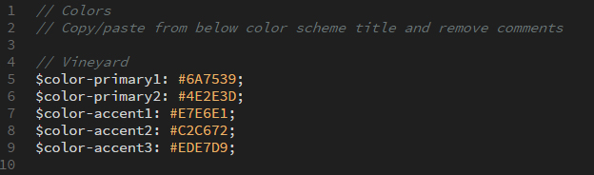

## Fonts

In order to customize the font package to match the blueprint you must copy and paste a font block from the bottom of **_variables.scss** and paste it over the existing font block at the top. Finally, remove the comments from all the lines that start with a **$** or **@**. Simply put, do not remove the two forward slashes before the font name.

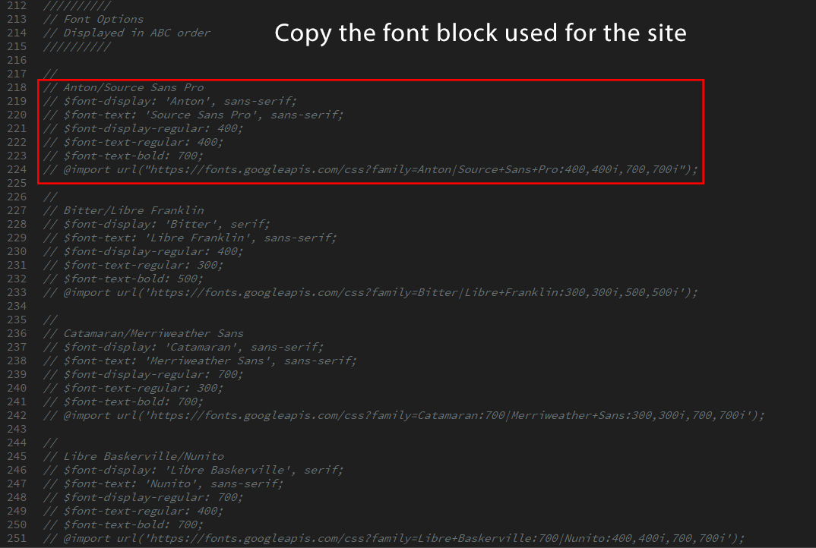

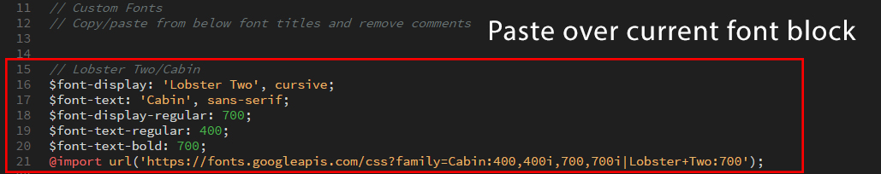

### *Trick* If you position your cursor here:

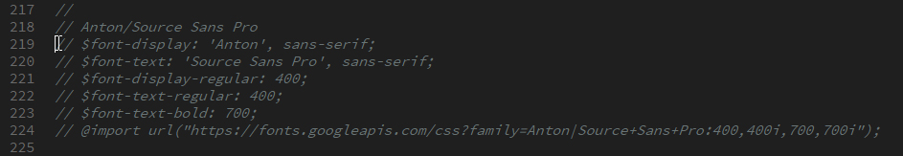

Hold down the “Alt” key and drag your cursor to the left and then down the page and you can easily select all the comment syntax:

*Note* Make sure you only delete the //’s that are in front of lines of code.

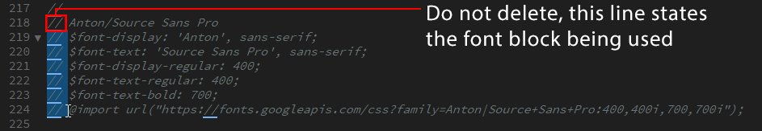

## Logo Alignment (Center or Left)

The logo scheme variable determines if the logo is centered or aligned to the left.

* For center alignment change the **$align** variable value to **center**.
* For left alignment change the **$align** variable value to **left**.

## 

Logo Alignment Example:

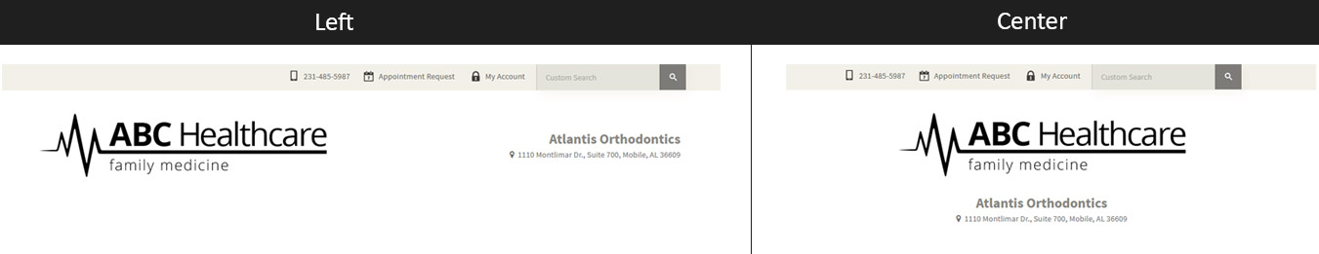

## Color Scheme (Light or Dark)

The color scheme variable determines which color publish link icon to pull. The first time you select light or dark you will be performing an educated guess. The best way to do this is to examine the **accent1** color. If the **accent1** color is a lighter color, then change the **$scheme** variable value to **light**. If the **accent1** is a darker color, then change the **$scheme** variable value to **dark**. After you compile, if the phone and published link text color doesn’t match the icon color, change the **$scheme** variable and recompile.



## Compiling

### Pre Compiling Checklist

Before you compile ensure you have done the following:

1. Adjusted your colors
2. Set your fonts

### How to Compile:

Compiling your **scss** folder takes your color/variable values and generates a **styles.css** file. You will then paste the contents of this file into the **Style Sheets** box of the **Template Details** in Presence.

1. In Dreamweaver ensure you have your **2017AtlantisStarter** server open
2. Expand the **Design3** folder so that the **scss** folder is visible
3. Right click the **scss** folder and click “Compile”
   1. Note this will take about 1+ minute, be patient

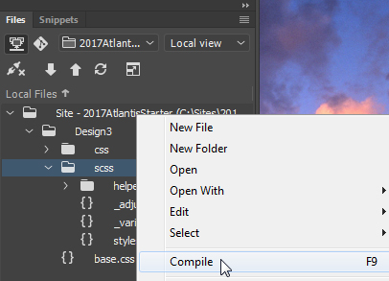

Make sure you have your **Output** tab open. If not, in the Dreamweaver tool bar, go to: Window – Results – Output. When your file is finished compiling, your **Output** tab will show the following:

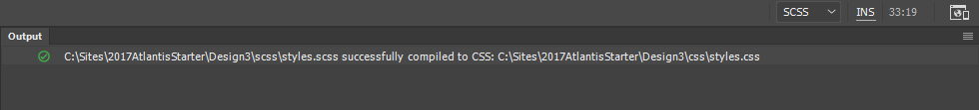

*** If there are **ANY** errors you must check your _variables.scss and **RECOMPILE.**

### Post Compilation

Expand the **css** folder you created earlier and open **styles.css**. Copy and paste all the contents into the **Style Sheets** box of your site **Template Details**. *Note* if the site contains added site-specific styles they should be located, with comments, at the top of the **Style Sheets** box, do **NOT** replace these styles. Again, all the styles from your newly compiled **styles.css** should be pasted below any site-specific styles.

## Header Phone Number

Editing the primary phone number for the Atlantis starter is very simple! Go to the **Template Details** screen and in the **Template Layout**, locate the following code and change the phone number:

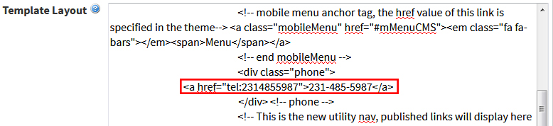

## Published Link Icons

When adding the published links to a site, there is a **CSS Class** field in the **Published Link Details**. This class is what generates the icon. Please add one of the listed classes below to each published link:

arrow 

blank (no icon)

calendar 

doctor 

email 

form 

healthcare 

lock 

phone 

pin 

prize 

reviews 

tooth 

## Address to the right of Logo

*This section goes away on any device under 1024px; visible on desktop only. Go to the **Template Details** screen and in the **Template Layout**, locate the following code and change the information:

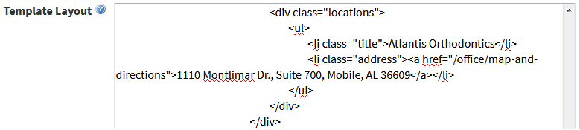

The **class="title"** style the large text. (This is also designed for links, in case phone number is used)

The **class="address"** styles the pointer icon.

For multiple addresses, just keep adding more lists with the correct classes:

**<ul>**

**<li class="title">Main Office</li>**

**<li class="address"><a href="/office/map-and-directions">1110 Montlimar Dr., Suite 700, Mobile, AL 36609</a></li>**

**<li class="title">South Office</li>**

**<li class="address"><a href="/office/map-and-directions">1110 Montlimar Dr., Suite 700, Mobile, AL 36609</a></li>**

**</ul>**

## Banner Images

Use the **Advanced Banner** portlet with **Advanced Banner 2017** as the Render Template. Use the Contained images in the Global Library. For custom images, suggested dimensions are: **800px width x 480px height**

## Callouts to the right of Slideshow

This area consists of 2 portlets: Top is a **Content** portlet. Bottom is a **Callout** portlet. The text inside the Content portlet must be enclosed in a **p** tag. This is very important. For the Callout portlet use the **Callout – Text Only** Render Template. This only requires a Title and URL, no image.

## Right side of Content

### Choices: Feature portlet or Upcoming Events portlet

**Feature Portlet**  
For the Feature portlet use the **Feature – Divided** Render Template. This is designed to use icons in the image field, no images. They are thumbnail size, max-width is 100px. In the **Global Image Library** select the folder **2018**, then **Icons** and choose either black or white depending on the background color of the website.

**Upcoming Events Portlet**For the Upcoming Events portlet, the client must have a Calendar page setup.

### How to Setup a Calendar Page

Create a new Calendar page by selecting “Calendar Page” from the Admin tool bar.

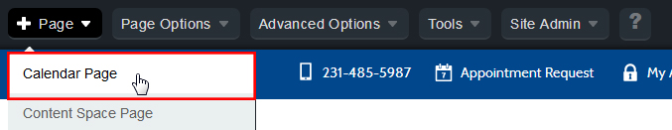

The calendar is automatically added to the new page. To add a new event, click the green “+” icon in the calendar tool bar.

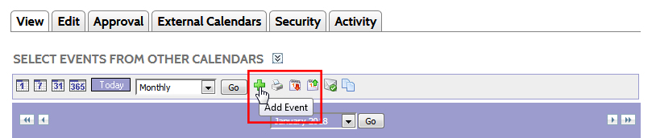

Fill out the fields needed for the event, then click “Create Event” at the very bottom. The first 4 fields are the information that will show up in the Upcoming Events portlet on the homepage.

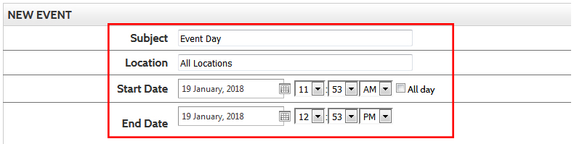

### How to Setup the Upcoming Events portlet on the Homepage

First, select the “Collaboration” portlet tab and drag & drop the “Upcoming Events” portlet to the portlet area. Click “Edit” and “Browse” for the calendar.

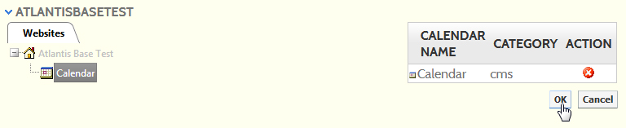

Click down through the tabs until you find the Calendar. Click “OK”. In the **Style** field, select “Custom Render Template” and “Events – Large Date”from the drop down menus. **Maximum Number of Events** is **5**. Click “Update Settings” and you should see all events, up to the first 5.

## Bottom Feature Area

### Choices: Feature portlet or Data Summary portlet

**Feature Portlet**   
For the Feature portlet use the **Feature – Divided** Render Template. Fill out the fields for Title, Image, Url and Description. For the images you can choose from the Global Image Library. (Horizontal photos look the best)

Starters are allowed 2-4 features. In the case that there are only 2 features, you may need to use larger photos because the images will be half the width of the website. Images will need to be least 600px wide.

**Data Summary Portlet (Blog Feed)**  
For the Data Summary portlet, the client must have a Blog page setup. It is recommended to have at least 2 blog posts. The Data Summary portlet will pull in the most recent blog entries, up to 4.

How to Setup a Blog Page  
Create a new Blog page by selecting “News/Blog Content Page” from the Admin tool bar.

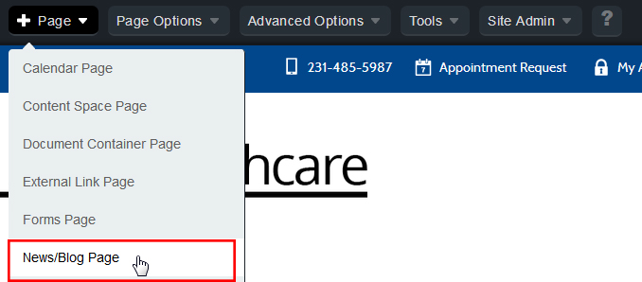

Switch to Design Mode and click “Edit” on the **Advanced Data Summary** portlet. In the Settings, **Rendered Data** should have **Page Data** selected. Browse to find the Blog page you just created. Make sure you click “Select” to the right of the Blog page.

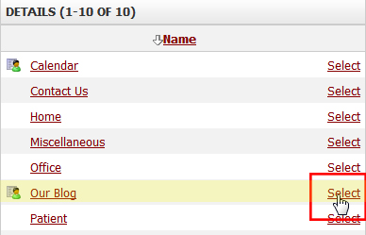

In the **Render Template** field choose **Default News Summary 2015 – Subpage** from the drop down menu. Leave the **Cache Timeout(Minutes)** field at **1**. Click “Update Settings.”

To create a Blog entry, first make sure you are on the main Blog page, and then click on “News/Blog Content Page” from the Admin tool bar. You will do this for each blog entry.

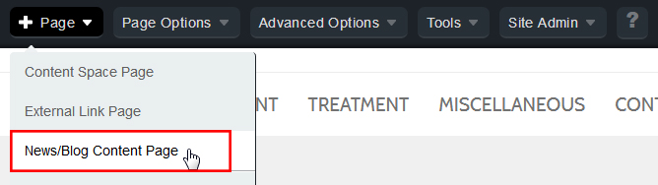

Switch to Design Mode and click “Edit” on the **Advanced Data Display** portlet. Fill out the fields needed for the blog, then click “Publish” at either the top/bottom. The fields below are the information that will show up in the Data Summary portlet on the homepage.

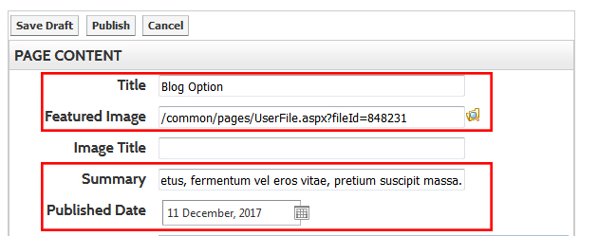

### How to Setup the Data Summary portlet on the Homepage

Drag & drop the “Data Summary” portlet to the portlet area. Click “Edit.” In the Settings, **Rendered Data** should have **Page Data** selected. Browse to find the Blog page you just created. Make sure you click “Select” to the right of the Blog page.



In the **Render Template** field choose **News – Divided** from the drop down menu. Leave the **Cache Timeout(Minutes)** field at **1**. Click “Update Settings” and you should see all the blog entries, up to the first 4.

## Custom Search Box (Optional)

1. Navigate to: <https://cse.google.com/cse/all>
2. Login with the Televox credentials:
   1. E-mail: televox17@gmail.com
   2. PW: Telepass!7
3. Click “Add” below **Edit Search Engines**

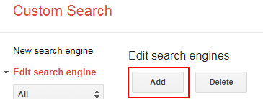

1. On the next window insert the **live site url** (without televox.west.com) into the “**Sites to search**” box. Leave the second box **empty**.

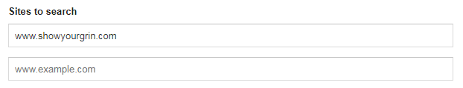

1. Click “**Create**” and on the next window click “**Get Code**”
2. Click “**Look and feel**” from the left hand navigation.
3. Click “**Results Only**” and then click “**Save & Get Code**”
4. Copy the top portion of the given code and paste it into notepad.

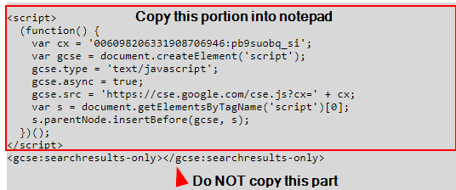

1. Navigate to the home page of your site and login as **admin**.
2. Click “**+ Page**” in the top left and then **click content space page**.
3. In the **Title** field name this page “**Search Results**”, the **Name** field should be “search-results”.
4. Click “**Create Page**”.
5. You should automatically be redirected to the new Search Results page, if not go ahead and navigate to this page.
6. From the top admin bar go to “**Page Options**” and then click “**Page Layout**”

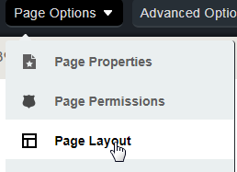

1. On the “**Edit Layout**” popup click the radio button labeled “**Custom**”.
   1. Paste the following code into the “**Custom Layout**” box:

**<template>&lt;gcse:Searchresults-only&gt;&lt;/gcse:Searchresults-only&gt;<column order="1" /></template>**

* 1. Click “**Check validation**”, the markup should validate.
  2. Scroll down to the bottom of the “**Edit Layout**” pop up and click “**Update Page**”.

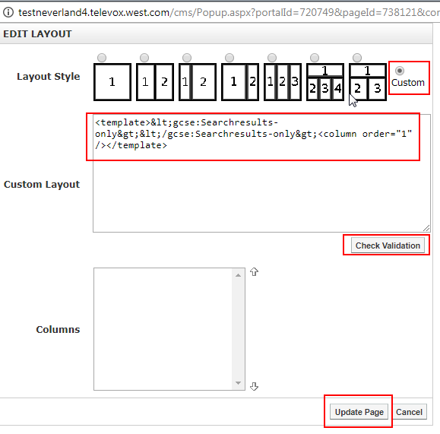

1. Navigate to **Administrate** and then **Manage Portal Themes** click “**Customize**” to go to the template editor.
2. Paste the following code into <div id=“topBar”> just before <div id=“showLinks”>:

**<div class="searchBox">&lt;gcse:Searchbox-only resultsUrl="/search-results"&gt;&lt;/gcse:Searchbox-only&gt;</div><!-- end searchBox -->**

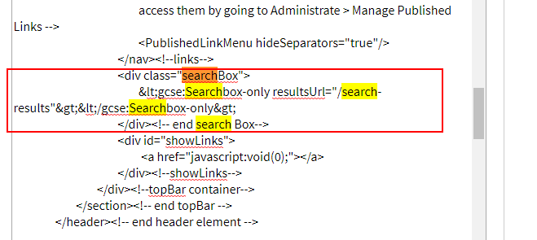

1. Next open **notepad** and copy the code you pasted into it earlier from Google.
2. Paste this code into your template directly before the closing “**HTMLhead**” tag.

Return to your site and the search bar should appear. **Note that search results will not show up until the site is live.** Test your search box by typing a term and pressing enter, ensure your search page looks correct.

The last step to adding a search box is to return to the home page and click “**Page Options**” and then “**Page Status**” from the dropdown. Click “**Hide Selection**” on the **Search Results** page and then click “**Close**”. The webpage should refresh and Search Results should no longer appear in the main menu.

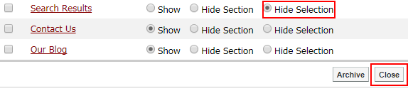

## Miscellaneous

### What if there’s additional custom CSS?

If the required CSS only needs to be on a single page please add it to a content portlet via style blocks. If for some reason your site requires additional global CSS you are to add it inside the commented custom CSS section. **\*Note* If you edit a site or have to recompile for whatever reason be very careful not to paste over the custom CSS section. You must also move the font @import statement to be at the very top of the Style Sheets text box.**

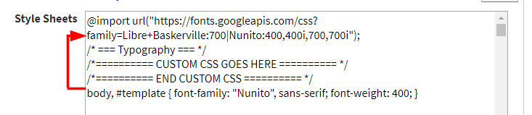

## What if two of the provided hex values are the same?

If two of your colors are identical on the blueprint simply **slightly** change one of the colors to be lighter or darker.