With the introduction of our first custom Presence starter template also comes a slight change in processes when developing a starter with this template. This will serve as a reference document for the Web Services development team and will contain instructions on how to properly build a site on this new starter template.

## Step 1 – Setting up a new server for SASS compiling (One Time Setup)

You should only have to do this step one time; its purpose is to provide a quick and efficient way of customizing and compiling the SASS for each Neverland Starter site.

1. Open Dreamweaver
2. On the “Files” tab click the server dropdown, scroll to the bottom and click “Manage Sites”
3. On the Manage Sites pop-up click “New Site” in the bottom right

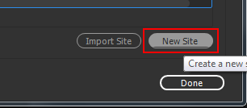

1. In the “Site Name” Field enter “2017NeverlandStarter
2. In the “Local Site Folder” click the folder icon, create a new folder named 2017Neverlandstarter, left click the folder and then click “Select Folder”

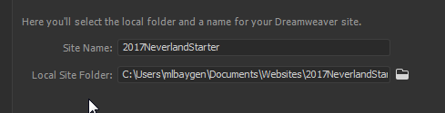

1. Keep the Site Setup pop-up open and in windows navigate to the P drive directory:
   1. **P:\WebDeveloper\Presence Platform\Starter Templates**
   2. Copy the “Design 1” folder to your clipboard
2. In windows navigate to the folder you just created for the new server and paste the Design 1 folder into it.
3. Back in Dreamweaver Click “Servers” from the left hand pane
4. Click the “+” icon in the middle of the right hand pane
5. This server information does **not** matter, we are simply creating a local server folder to compile CSS. Enter the following information into the fields:

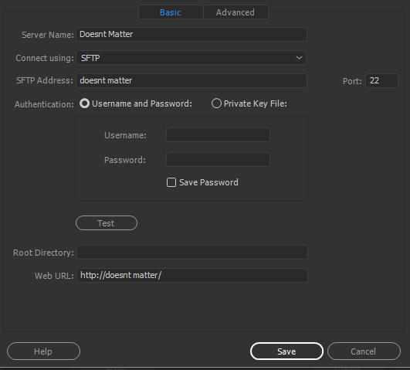

1. Click “Save”
2. Click “CSS Preprocessors from the left hand pane.
3. Uncheck “Enable autocompilation on file save”.
4. Click “Source & Output” from the left hand pane
5. Click the “Define output folder” radio button and then click the folder icon to the right

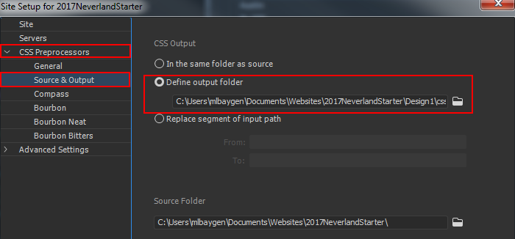

1. In the “Choose Output Folder” window double click the “Design 1” folder
2. Create a folder named “CSS” inside of the “Design 1” folder
3. Click the CSS folder and then click “Select Folder”
4. Click “Save”, and then click “Done” on the “Manage Sites” pop-up.

You are now setup and ready to compile your 2017Neverland SASS styles!

## Colors

In Dreamweaver go to your 2017NeverlandStarter server. In the files panel expand the “Design 1” folder, next expand the “SCSS” folder. Open the file named “_variables.scss”.

At the very top you will see 5 variables starting with $color-primary1. Change each of these variable values to the corresponding hex values provided on the blueprint.

The predefined color palettes can be found at the bottom of _variables.scss.

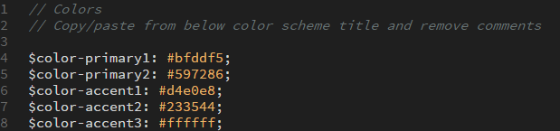

## Fonts

In order to customize your font package to match the blueprint you must copy and paste a font block from the bottom of **_variables.scss** and paste it over the existing font block. Finally you must remove the comments from all the lines that start with a “**$**” or “**@**”. Simply put, do not remove the two forward slashes before the font name.

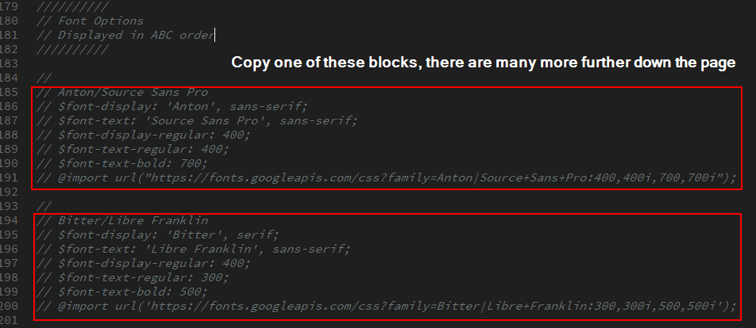

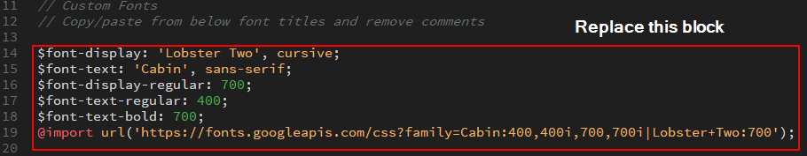

### *Trick* If you position your cursor here:

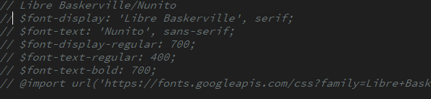

Hold “**alt**” and drag your cursor to the left and then down the page and you can easily select all the comment syntax:

*Note* Be sure you only delete the //’s that are in front of lines of code.

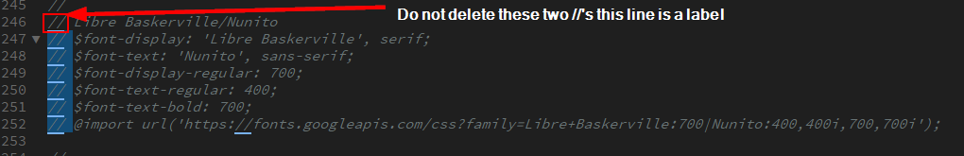

## Color Scheme (Light or Dark)

The color scheme variable determines which color publish link icon to pull. The first time you select light or dark you will be performing an educated guess. The best way to do this is to examine your **accent1** color. If this color is a lighter color change the “**$scheme**” variable value to light, if **accent1** is a darker color change the “**$scheme**” variable value to dark. After compilation, if the phone and published link text color doesn’t match the icon color, change the $scheme variable and recompile.



## Published Links & Icons

In Dreamweaver go to your 2017NeverlandStarter server. In the files panel expand the “Design 1” folder, next expand the “SCSS” folder. Open the file named “_variables.scss”.

Find the section labeled “Icons”, you will see a variable definition. Change the values of the variable to the icons you want your published links to display. Note you must list your icons in the order of which they appear on your site. If one of your published links does not need an icon use the value “**blank**”. *Note* do not include the primary phone number in the published links menu, add it manually to **<div class=”phone”>** in the template. **If your site does not have any published links add the word null inside of the parentheses.**



## Compiling

### Pre Compiling Checklist

Before you compile ensure you have done the following:

1. Adjusted your colors
2. Set your fonts
3. Selected your scheme (light or dark)
4. Added the phone number to the template
5. Added the published links into the Presence back end
6. Set your published links icons in the **_variables.scss**

### How to Compile:

Compiling your scss folder takes your color/variable values and generates a **style.css** file. You will then paste the contents of this file into the bottom box of the template editor in Presence.

1. In Dreamweaver ensure you have your 2017NeverlandStarter server open.
2. Expand the Design1 folder so that the SCSS folder is visible.
3. Right click the SCSS folder and click “Compile”
   1. Note this will take about 1+ minute, be patient.

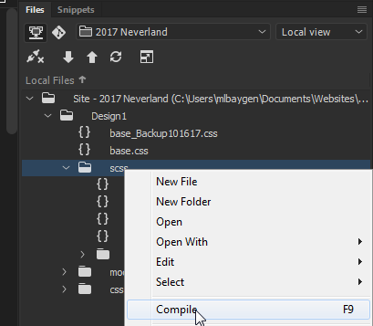

When your file is finished compiling your output tab at the bottom of Dreamweaver will show the following:



*** If there are **ANY** errors you must check your _variables.scss and **RECOMPILE.**

### Post Compilation

After your file has completed compiling you should notice a new folder titled “**CSS**” under “**Design 1**”. Expand this folder and copy the contents of “**style.css**”. Paste this into the bottom styles box of your site template editor. *Note* if the site contains added site-specific styles they should be located and commented at the top of this box, do **NOT** replace these styles. Replace all the styles below with the contents of your compiled **style.css.**

## Addresses

### If an office has 2 or less locations:

#### Header:

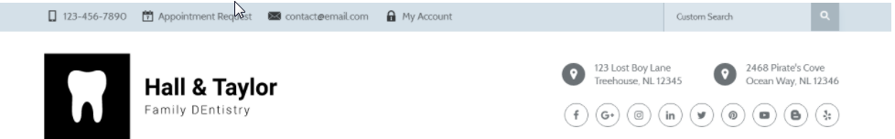

Edit the site’s template code and update the addresses to match the blueprint.

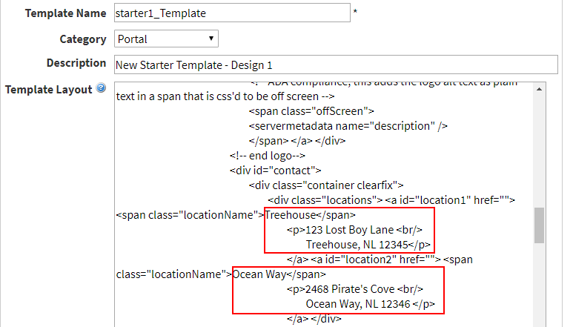

#### Footer

Delete the map portlet and the bottom address section from the footer extension. Next, edit the two addresses beside the contact us paragraph to match the blueprint. To do this simply go into edit mode and edit the content portlet in this area. Be careful not to change any of the markup and definitely do NOT use design mode.

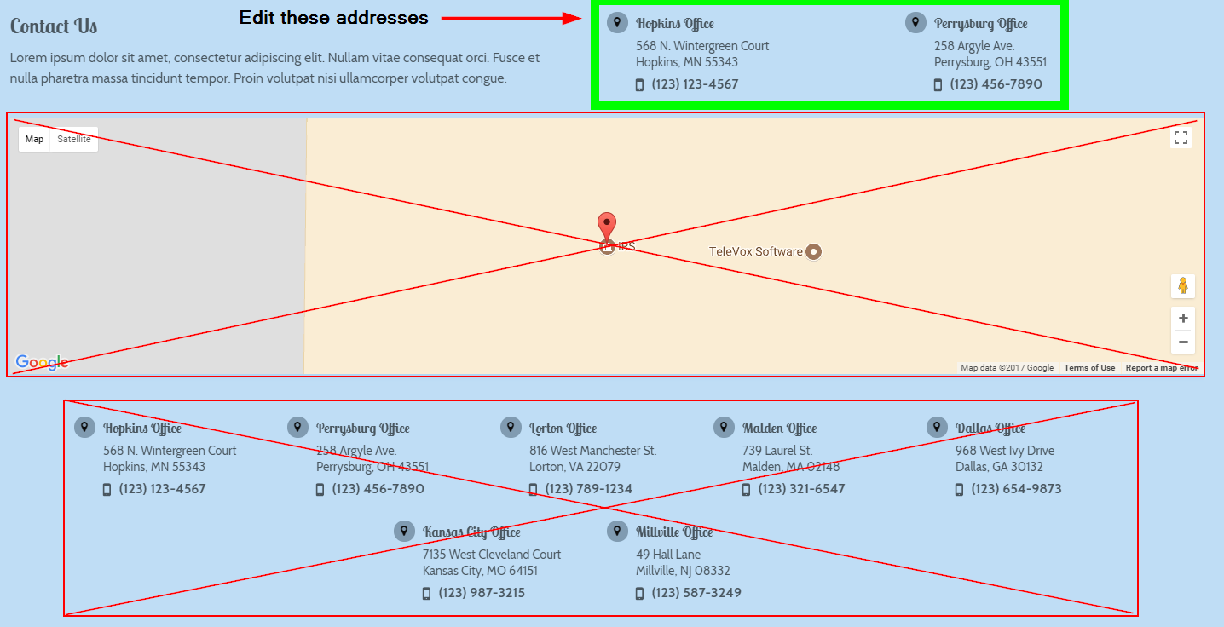

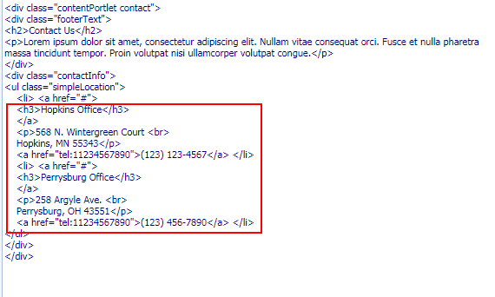

### If an office has 3 or more addresses:

#### Header:

Edit the first header address to match the primary location. Next, edit the second address to say “**X** convient locations in the **Y** Area” with locationName “See additional locations”. **X** being the additional number of locations, and **Y** being the area. In the event the client does not want a primary address displayed, be sure location number includes ALL locations and locationName reads “Choose a location”. Be sure you do not change the markup when editing the template. Ex:

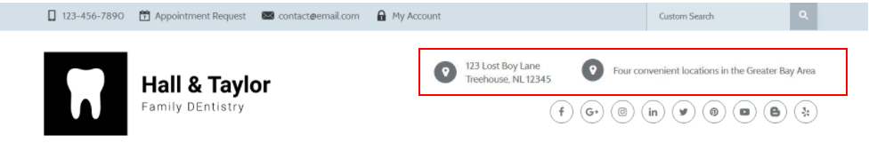

#### Footer:

Next, delete the top content portlet in the footer extension and edit the addresses below the map to match the blueprint.

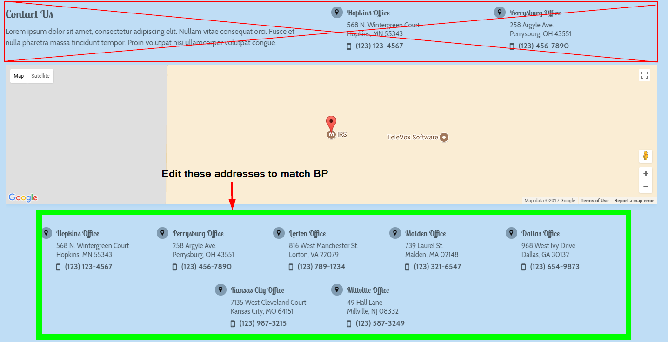

## Header Phone Number

Editing the primary phone number for the Neverland starter is very simple! Open Manage Portal themes, and then click “**Customize**” to go to the template editor. In the template locate the following code and change it to the new value:

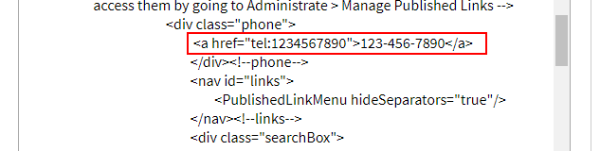

## Custom Search Box

1. Navigate to: <https://cse.google.com/cse/all>
2. Login with the Televox credentials:
   1. E-mail: televox17@gmail.com
   2. PW: Telepass!7
3. Click “**Add**” below “Edit Search Engines”

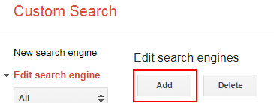

1. On the next window insert the **live site url** (without televox.west.com) into the “**Sites to search**” box. Leave the second box **empty**.

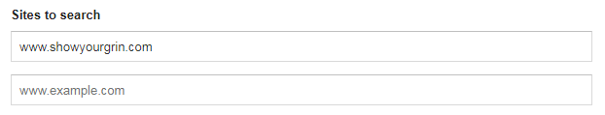

1. Click “**Create**” and on the next window click “**Get Code**”
2. Click “**Look and feel**” from the left hand navigation.
3. Click “**Results Only**” and then click “**Save & Get Code**”
4. Copy the top portion of the given code and paste it into notepad.

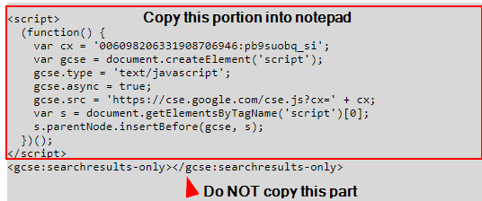

1. Navigate to the home page of your site and login as **admin**.
2. Click “**+ Page**” in the top left and then **click content space page**.
3. In the **Title** field name this page “**Search Results**”, the **Name** field should be “search-results”.
4. Click “**Create Page**”.
5. You should automatically be redirected to the new Search Results page, if not go ahead and navigate to this page.
6. From the top admin bar go to “**Page Options**” and then click “**Page Layout**”

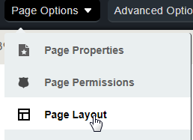

1. On the “**Edit Layout**” popup click the radio button labeled “**Custom**”.
   1. Paste the following code into the “**Custom Layout**” box:

**<template>&lt;gcse:Searchresults-only&gt;&lt;/gcse:Searchresults-only&gt;<column order="1" /></template>**

* 1. Click “**Check validation**”, the markup should validate.
  2. Scroll down to the bottom of the “**Edit Layout**” pop up and click “**Update Page**”.

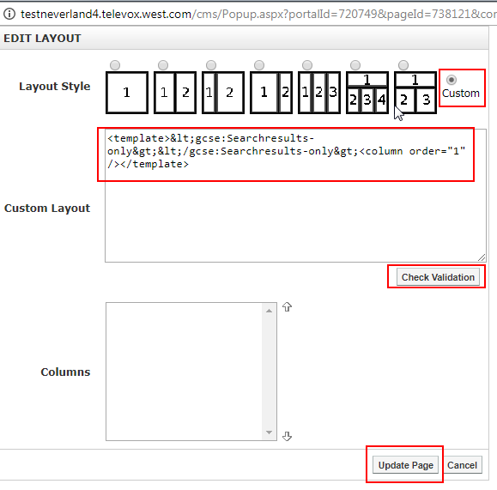

1. Navigate to **Administrate** and then **Manage Portal Themes** click “**Customize**” to go to the template editor.
2. Paste the following code into <div id=“topBar”> just before <div id=“showLinks”>:

**<div class="searchBox">&lt;gcse:Searchbox-only resultsUrl="/search-results"&gt;&lt;/gcse:Searchbox-only&gt;</div><!-- end searchBox -->**

1. Next open **notepad** and copy the code you pasted into it earlier from Google.
2. Paste this code into your template directly before the closing “**HTMLhead**” tag.

Return to your site and the search bar should appear. **Note that search results will not show up until the site is live.** Test your search box by typing a term and pressing enter, ensure your search page looks correct.

The last step to adding a search box is to return to the home page and click “**Page Options**” and then “**Page Status**” from the dropdown. Click “**Hide Selection**” on the **Search Results** page and then click “**Close**”. The webpage should refresh and Search Results should no longer appear in the main menu.

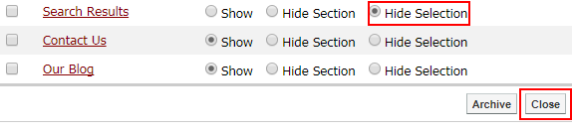

## Banner Images

**The 2017 Neverland starter template does NOT have or offer a slideshow on the home page.** It contains one full width feature box that contains a title, text, and a read more link. Clients can request to change this banner feature image to a photo of their office or to one of our newly uploaded Neverland banner images. Suggested dimensions are: **1920px width x 1280px height. Be sure all new images are compiled to under 150kb(use** [**http://compressjpeg.com/**](http://compressjpeg.com/)**, add image, hover and click settings cog to adjust compression as low as possible), any quality lost will be masked by CSS blur.** Note if the feature contains a lot of text the image will fade into a solid color to accommodate.

To change this image:

1. Navigate to the home page and turn **design mode ON**.
2. Click the pencil icon in the top right of the feature box
3. Expand the single feature box entry by clicking the “**+ symbol**”
   1. 
4. Click the **folder icon** next to the image path.
5. Using the image browser that pops up ensure you are in the **Global Image Library**.
6. Navigate to **Starter Resources > 2017Neverland > Banner Images**. You may choose any of the images in this folder and then click **Insert**.
   1. 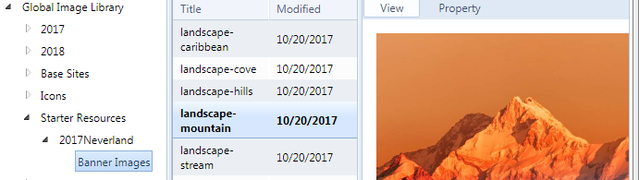
7. Finally click “**Save**”.

## Featured Images

The 2017 Neverland Starter template contains **one featured image per main menu item**. These featured images appear behind the h1 and breadcrumbs on every interior page.

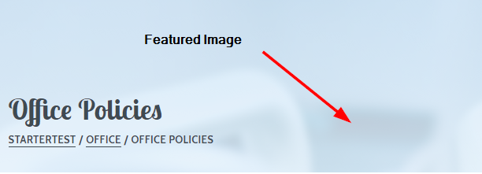

We can customize these images for our clients by following these steps:

1. Navigate to the **Main Menu Parent Page** ex: (Office, Patient, Treatment, etc..)
2. On the admin bar click **Page Options,** and then **Page Properties.**
3. On the **Page Properties** pop up ensure that the **Theme** field is set to the interior theme and **NOT** inherit.
4. On the **Featured Image** field click the **Folder & Hour Glass** icon.
5. Just like we did for the banner image, ensure you are navigating the **Global Image Library** and go to: **Starter Resources > 2017 Neverland > Banner Images**.
6. Click any of the images in this folder and then click “**Insert**”.
7. Click “**Update Page**”

The image will appear as long as the theme is manually set to the interior theme and a featured image is selected.

## Office Hours

The 2017 Neverland Starter template contains a hard coded content portlet on every interior page which displays **Office Hours**. This content portlet can be customized to contain any responsive content the client wishes to add.

**\*NOTE* We are NOT to add any additional portlets to this pageset. I repeat DO NOT ADD ANY ADDITIONAL PORTLETS TO THIS PAGESET!!!!!!**

To edit the content of this portlet:

1. Navigate to any interior page and turn **design mode on**.
2. Click the **pencil** icon on the Hours – Aside portlet
3. Edit the hours or content to your liking.
   1. If you are simply updating the hours I’d highly suggest using HTML mode so you do not compromise the markup of the portlet.
   2. If you are adding other content be sure to test it all the way down to **320px** in width.
4. Click “**Save**” in the top left.

## Miscellaneous

### What if there’s additional custom CSS?

If the required CSS only needs to be on a single page please add it to a content portlet via style blocks. If for some reason your site requires additional global CSS you are to add it inside the commented custom CSS section. **\*Note* If you edit a site or have to recompile for whatever reason be very careful not to paste over the custom CSS section. You must also move the font @import statement to be at the very top of the stylesheets text box.**

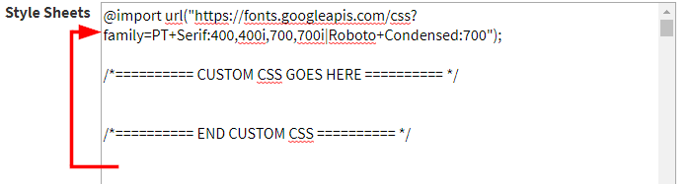

## What if two of the provided hex values are the same?

If two of your colors are identical on the blueprint simply **slightly** change one of the colors to be lighter or darker.

## Disable Telerik Menu Animations

**Whenever you build one of the new starters, Neverland, Olympus, or Atlantis. You need to disable the Telerik animations.**

**Administrate > Manage Control Settings > Telerik CMS Menu Tab**

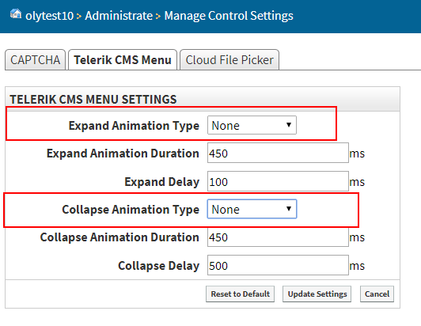

Be sure both of the boxes highlighted above are set to None.