# Calendar Portlet Color Customization

The calendar portlet is currently using an outdated UI that is slated for an update. Due to the uncertainty surrounding that update, all Starter calendars will use default color styling for everything but the calendar head and border. Essentials calendars should have **minor** customization just to fit with the design of the site.

## How to change the calendar color

1. On the calendar page, select “Edit” from the tabs at the top of the calendar

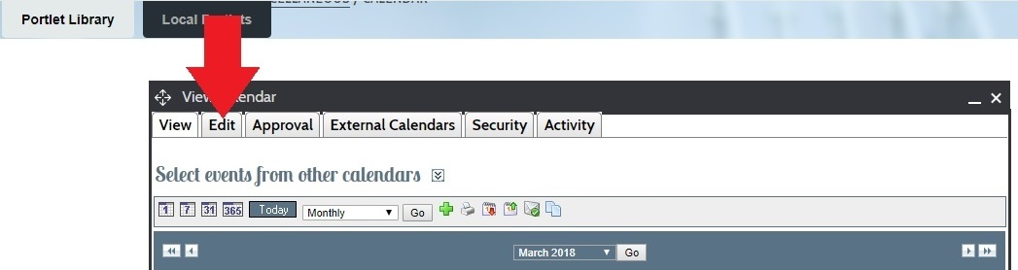

1. On the “Edit Calendar” screen, click the color swatch just below the calendar name.

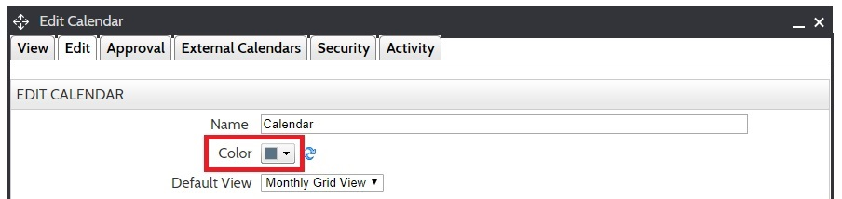

1. Once the color picker pops up, click the “HSB” button at the bottom.

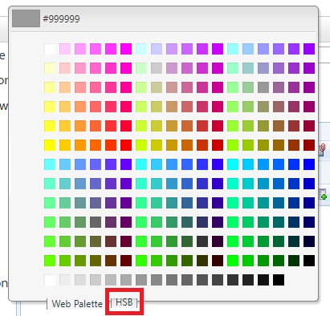

1. Copy the desired hexcode (for Starters, see the list below) and paste it into the box on the top left of the color picker, then click “Apply”.

**For Essentials:** *Note that this color should be dark enough for white text to be readable.*

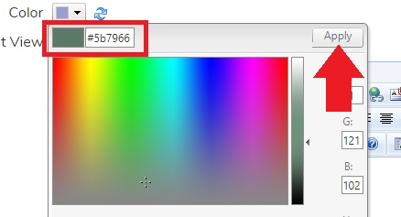

1. Click “Update Calendar” at the bottom of the screen to return to the main calendar view.

You have successfully changed the calendar color! Note that the calendar background and text colors will not change from the default. Only the top header and calendar border color (purple by default) will change.

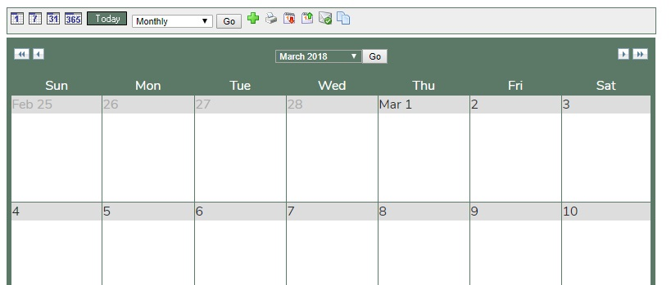

## Starter Colors

Aquarium: #0171B7

Blush: #9E445D

Campus: #1B4167

Carnival: #084BA0

Creek: #826E5D

Desert: #5B7966

Disco-dark: #7705BF

Disco-light: #6810A0

Glamour-dark: #4F4E4C

Glamour-light: #4E4D4C

Gunmetal: #984F43

Jewel: #045E6D

Lake: #597286

Magma: #7B0903

Primary: #0A77D6

Rainforest: #1C6305

Reef: #0171C3

Rustic: #A45A11

Shoreline: #5A7784

Vineyard: #4E2E3D